- Copy the tzupdater-1[2].1.0-2007c.zip file to your hard drive and unzip it.
- Perform a search for java.exe in Windows Search to locate all java versions on the PC that should be patched. You should patch any java.exe that resides in a
<Java Home>\jdk\jre\bin example: c:\oracle10gids\jdk\jre\bin
<Java Home>\jdk\bin, or
<Java Home>\jre\<version#>\bin.
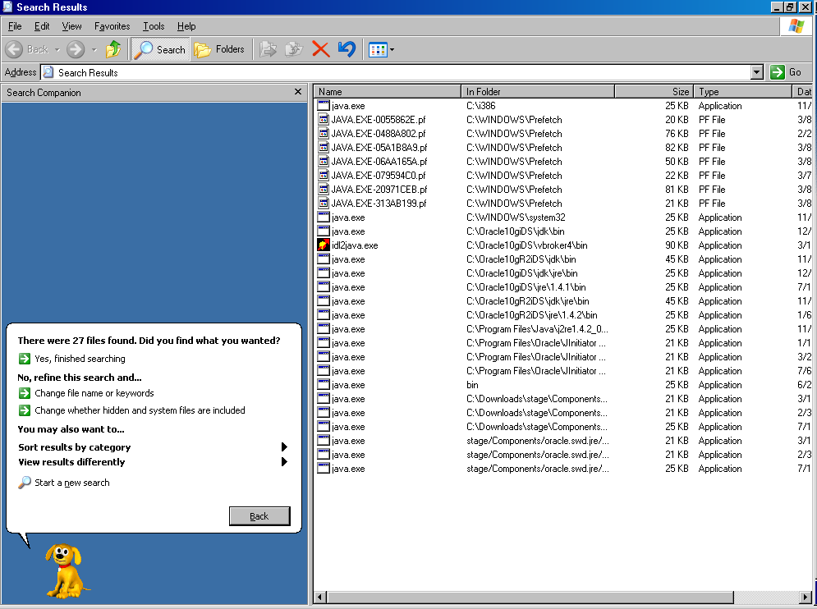
- Access the command line by clicking Start→Run then type cmd and press Enter.
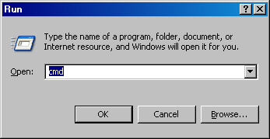
- When the command line session opens, change directory to your C: drive.
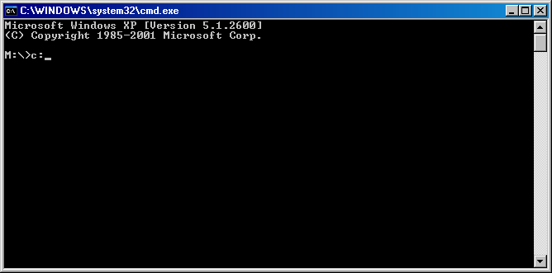
- Change directory to the location of the tzupdater that you just unzipped then change directory into the tzupdater-1.1.0-2007c directory.
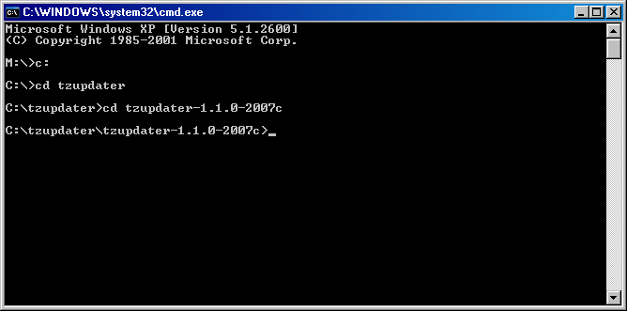
- To test the identified java versions and verify that they haven’t been updated for the TSD, type <java path>\java –jar tzupdater.jar –t.

example: c:\oracle10gids\jdk\jre\bin\java –jar tzupdater.jar –t

If the JDK has been updated then it will pause for a couple of seconds and then return with no other response. If the JDK has not been updated then it will return a list of items that will be updated when run the tzupdater.
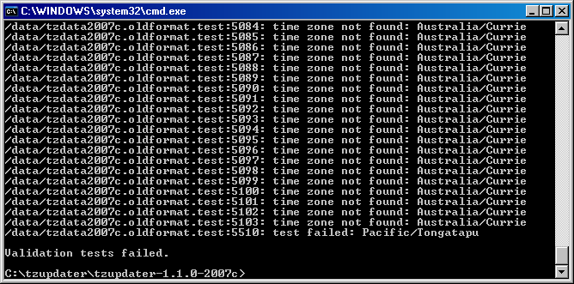
- If the test returns with a list of items, then type <java path>\java –jar tzupdater.jar –u to update the time zone information in the JDK. It will pause for a couple of seconds and return with no response.
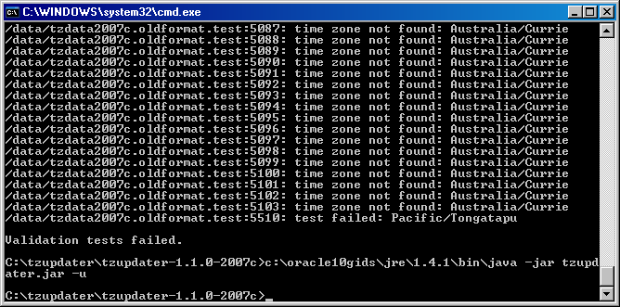
- To verify that the update has occurred successfully, type <java path>\java –jar tzupdater.jar –t a second time. It should return without a list of items if the patch was successful.
- Type exit to close the command line session.

