Top of Form
Bottom of Form
Home | Find a Park | Events | Activities | Park Guide | Contact Us | Make us your Homepage
Florida State Parks Monthly Newsletter

"The Battle of Olustee was a significant Civil War event that involved thousands of soldiers." ~Mike Bullock Florida Park Service Director  Olustee Battlefield Historic State Park welcomed visitors to the 143rd anniversary of Florida’s largest civil war battle. On February 16-18. The event featured more than 2,000 actors portraying the roles of civilian and military life during the 1860s. | 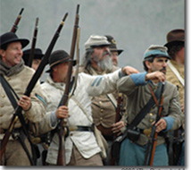
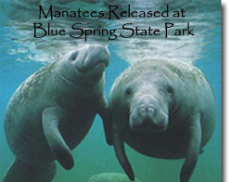 | Blue Spring State Park released two Lowry Park Zoo manatees as a part of the Manatee Rehabilitation Partnership (MRP). Wildlife experts returned the manatees, named “Dundee” and “Gene,” to their natural habitats after being rehabilitated in manatee holding facilities for several years.  Manatees are a unique natural resource in the state of Florida,” said Florida State Parks Director Mike Bullock. “The Florida Park Service is honored to be a partner in the stabilization of this endangered species.”  For more information about the MRP and manatees currently being tracked, visit http://www.floridastateparks.org/bluespring/Activities.cfm
Florida Park Service  Celebrates Women’s History Month  The Florida Park Service will join the National Park Service to host a dedication ceremony at Marjorie Kinnan Rawlings Historic State Park on March 3. The event will celebrate the recent designation of the home of Marjorie Kinnan Rawlings as a National Historic Landmark. http://www.floridastateparks.org/marjoriekinnanrawlings/default.cfm | Marjorie Kinnan Rawlings Historic State Park  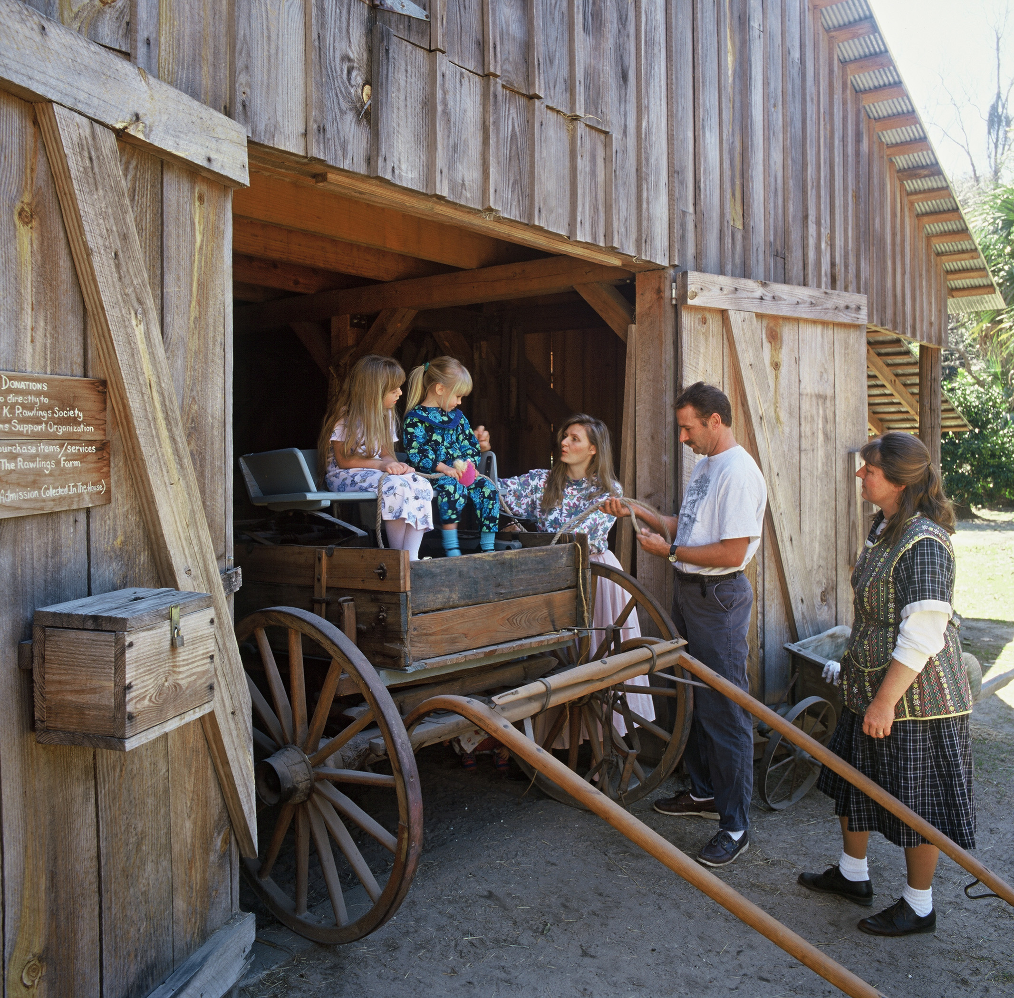
Some of the upcoming events at Florida State Parks

FLORIDA CONSTITUTION DAYS
Constitution Convention Museum State Park
Date: Friday/Saturday, March 9-10th from 9:00am to 3:00pm
Description: T.H. Stone Memorial St. Joseph Peninsula State Park and the Constitutional Convention Museum State Park will be presenting demonstrations of life as it was in the 1830’s. This event is designed to exhibit the skills and lifestyles of the inhabitants of St. Joseph during a time when Florida’s first Constitution was signed at the Constitutional Convention in 1838. Demonstrations will consist of soap making, candle making, rendering lard and cracklings, sewing demonstrations, turpentine and still demonstrations, among others. Guided tours of the museum will be offered. Fees will be waived for the event, and donations to help the Friends of Saint Joseph State Park will be accepted.
Fees: Entrance fees waived for event
Contact: (850)227-1327
Directions: Constitutional Convention Museum State Park is located in Port St. Joe, off U.S. 98.
THE 2ND ANNUAL RIVERFEST
Wekiwa Springs State Park
Date: March 10, 2007, 10:00 a.m. - 4:00 p.m.
Description: Join nature artists and authors, musicians, Wekiwa Springs State Park, and the Friends of the Wekiva River in celebrating the federally designated Wild and Scenic River! Activities include hikes, children's nature crafts, book-signings and entertainment.
Fees: Free Admittance.
Contact: Contact park for more information.
Directions: Wekiwa Springs State Park is approximately 20 minutes North of Orlando and approximately 45 minutes North of the attractions. It is easily located off Interstate 4 at exit 94. Take State Road 434 West to Wekiwa Springs Road. Turn right on Wekiwa Springs Rd. and travel approximately 4 miles to the park entrance which will be on the right. Please call the park if additional directions are needed.
11TH ANNUAL AZALEA DAYS
Ravine Gardens State Park
Date: March 10, and 11, 2007, 9:00 a.m. - 4:00 p.m.
Description: Come enjoy a ranger-led hayride around a 1.8 mile loop of thousands of blooming azaleas, while listening to the unique history of this park. Learn why Ravine Gardens played an important role in the economic recovery of the City of Palatka. The extensive hiking trail system located at the bottom of the ravine gives our visitors a spectacular view of color and beauty including azaleas, dogwoods, magnolias and camellias. Vendors and crafters will be located around the Court of States within the park. The Art League and CREATE will be located in the Civic Center. Also located this year in the Civic center will be an Archaeological display provided by the Saint Augustine Public Archaeology Regional Center. The sounds of music, by some local and non-local entertainers, will echo throughout the ravines. Food and refreshments will also be available through-out the park. For more information and vendor applications contact Donna Rhein Masse at Ravine Gardens State Park (386) 329-3721.
Fees: Park entrance fees.
Contact: Donna.Masse@dep.state.fl.us
Directions: Ravine Gardens State Park is located in Palatka, Florida. From US17/SR100, turn south onto Moseley Avenue, then turn east onto Twigg Street.
SPANISH AMERICAN WAR EVENT
Fort Clinch State Park
Date: Saturday and Sunday, March 10 & 11, 2007.
Description: Commemoration of the Spanish American War.
Fees: Park entrance fee plus $2.00 per person Fort admission.
Contact: Call 904-277-7274 for information.
Directions: Take I–95 to the Fernandina Beach/Callahan exit (Milepost Exit 373 - Old Exit 129), and stay to the right. You will then be traveling east on A1A. (This road becomes 8th Street within the town limits of Fernandina.) Stay on this road, (A1A), for 16 miles until you come to the intersection of 8th Street and Atlantic Avenue. Turn right on Atlantic Avenue and go about two miles, Fort Clinch State Park will be on the left.
FLORIDA'S GREAT ESCAPE TRIATHLON
Lake Louisa State Park
Date: March 11, 2007 6:00 am- 1:00 pm
Description: Triathlon. Swim 500 yds, Bike 16 miles, Run 3 miles. Qualifier for the Escape from Alcatraz Triathlon .
Fees: $85.00 entry fee.
Contact: www.usantc.com
Directions: Lake Louisa State Park is located on US 27, seven (7) miles south of State Road 50.
CIVIL WAR ENCAMPMENT
Silver River State Park
Date: March 16 - 18, 2007
Description: Our reenactors are back! Come out and witness drills and parades in a realistic setting that takes you back in time. Check back here closer to the date for more detailed information.
Fees: $4.00 park entry fee or $3.00 single occupancy vehicle
Contact: deborah.wilson@dep.state.fl.us
Directions:
Silver River State Park is located east of Ocala, 1 mile south of S.R. 40 on S.R. 35. From Interstate 75, take exit 352 onto SR 40 east, about 9 miles to SR 35. From Interstate 95 take exit 268 to Route 40 west, about 60 miles to SR 35.

FORT COOPER DAYS
Fort Cooper State Park
Date: Saturday & Sunday, March 17th & 18th, 2007. 9:00 a.m. to 4:00 p.m.
Description: Re-live Second Seminole War activities that took place on this site. Battle reenactments at 11am and 2pm. Also features living history demonstrations, sutlers, period art and craft vendors, entertainment, food and refreshments. Hosted by the Friends of Fort Cooper.
Fees: Fees: $ 5.00 per adult, Children 6 to 17 years of age $ 1.00. Children under 6 – free.
Contact: For more information, call 352-726-0315.
Directions: Fort Cooper State Park is located just off US 41, on South Old Floral City Road, two miles south of Inverness.
WILD AZALEA FESTIVAL
Stephen Foster Folk Culture Center State Park
Date: Saturday, March 17, 2007. 9:00 a.m. to 4:00 p.m.
Description: This event will take place at the State of Florida’s Nature & Heritage Tourism Center in White Springs. Join the Town of White Springs and the State of Florida’s Nature & Heritage Center as they celebrate the spring bloom of wild azaleas along the Suwannee River. The festival features musical performances, arts and crafts, trail hikes and other outdoor recreational opportunities. Native plants, including wild azaleas will also be for sale. Visitors will be able to take a free ride on a horse-drawn wagon. The event is sponsored by the Nature & Heritage Tourism Center and the White Springs Special Events Committee.
Fees: This event is free!
Contact: For more information, call 386-397-7005.
Directions: Located on U.S. 41 in White Springs. From I-75 to S.R. 136 (Milepost Exit 439 - Old Exit 84), travel east on S.R. 136 for 3 miles. Turn left on U.S. 41. Park entrance is on the left. From I-10 to U.S. 41 North (Milepost Exit 301 - Old Exit 43), travel 9 miles to White Springs. Park entrance is on the left.
ELDERHOSTEL
Stephen Foster Folk Culture Center State Park
Date: Sunday through Friday, March 18 through March 23, 2007.
Description: Explore North Florida’s natural beauty and local culture along the Suwannee River in our learning programs for adults age 55 and older. Leisure, active or service programs are available. Learn more about the life and music of Stephen Foster. Enjoy church suppers, local musicians and craftsmen, or canoe and hike along the Suwannee.
Register online at Elderhostel - Adventures in Lifelong Learning.
Fees: Registration fees apply.
Contact: For more information, call 386-397-7005.
Directions: Located on U.S. 41 in White Springs. From I-75 to S.R. 136 (Milepost Exit 439 - Old Exit 84), travel east on S.R. 136 for 3 miles. Turn left on U.S. 41. Park entrance is on the left. From I-10 to U.S. 41 North (Milepost Exit 301 - Old Exit 43), travel 9 miles to White Springs. Park entrance is on the left.
THE FLORIDA STATE SINGLE SPEED CHAMPIONSHIPS
Alafia River State Park
Date: March 18, 2007
Registration: 7:00 AM - Race Begins at 9:30 AM
Description: Brought to you by Red Trail Racing Inc. and the SouthWest Association of Mountainbike Pedalers. The skill level and length of the course will be similar to typical cross country style races using only one gear. Races will include both men's and women's intermediate and expert classes, as well as different age categories. Cash prizes will be awarded for the top 3 expert class finishers and other prizes for all top 3 finishers in all classes. For more information please log onto Redtrailracing.com
Fees: Park admission fees apply.
Contact: Contact the park at: 813-672-5320
Directions: From the South - Take I-75 North to exit #240. At exit #240, turn Right (East) onto SR 674. Keep straight on SR 674 for approximately 15 miles. Turn Left (North) at flashing light, onto CR 39 for approximately 5 miles. The main park entrance is on the Right side. From the North - Take I-75 South to exit #246. At exit #246, turn Right (East) onto Big Bend Road. Keep straight on Big Bend Road for approximately 1 mile. Turn Right (South) onto U.S. 301. Keep straight on U.S. 301 for approximately 1.5 miles. Turn Left (East) onto CR 672. Follow CR 672 for approximately 12 miles. Turn Left (North) onto CR 39. Keep straight on CR 39 for approximately 1.5 miles. The main park entrance in on the Right side. From the East - Take I-4 West to exit #22. Turn Left onto Park Road. Follow Park Road for approximately 2.5 miles. Bear right onto 39B. Turn Left onto SR 39 (James Redman Parkway). Continue on SR/CR 39 for approximately 15.2 miles. The main park entrance will be on the Left side.
9TH ANNUAL SAWGRASS FIDDLE FESTIVAL
Paynes Prairie Preserve State Park
Date: Saturday, March 24th, 2007. Registration begins at 9:00 a.m.
Description: To learn more about this fiddle contest for children and teens taking place at Paynes Prairie go to Sawgrass Fiddle Contest
Fees: Please see Sawgrass Fiddle Contest web site.
Contact: For more information, call 352.374.8798
Directions: Paynes Prairie Preserve State Park is located 10 miles south of Gainesville, in Micanopy, on the east side of US 441.
Coming from the north on I-75: Take exit 374, the Micanopy exit, and turn left at the end of the exit ramp. You will then be traveling east on CR 234. Stay on this road 1.4 miles until it intersects with US 441. Turn left onto 441 and go 0.6 miles to Paynes Prairie Preserve State Park (on the right).
Coming from the south on I-75: Take exit 374, the Micanopy exit, and turn right at the end of the exit ramp. You will then be traveling east on CR 234. Stay on this road 1.4 miles until it intersects with US 441. Turn left onto 441 and go about 0.6 miles to Paynes Prairie Preserve State Park (on the right).
HOW TO IMPROVE YOUR PHOTOGRAPH!
Savannas Preserve State Park
Date: March 24, 2:00 PM - 5:00 PM
Description: Join us on March 24 as professional photographer Irv Friedman presents a basic photography workshop. Mr. Friedman specializes in performing and visual arts photography, and encourages photographers of all skill levels and interests to attend. Participants should bring a camera - film or digital - and a few favorite photographs to be critiqued. Call (772) 398-2779 to reserve a space.
Fees: Free
Contact: (772) 398-2779
Directions: The Environmental Education Center is located approximately 2 miles east of US 1 on Walton Road in Port St. Lucie.
RED HILLS TRIATHLON
Alfred B. Maclay Gardens State Park
Date: Saturday, March 24th from 4:30am to 12:30pm
Description: The sixth annual Red Hills Triathlon is an officially sanctioned race event. Triathlon is a three-phase, athletic event that begins with swimming, followed by bicycling and finishes with a run.
The Race Director is Kathy McDaris. She can be contacted at; racedirector@redhillstriathlon.org
This contact link is also on the opening page of; www.redhillstriathlon.org, titled “Ask the Race Director”.
Fees: Call Maclay Gardens for fees and futher information
Contact: (850)487-4115
Directions: Maclay State Gardens is located one half mile north of I-10 on U.S. 319.
SIGNIFICANT VALUE OF PRIVATE ARTIFACT COLLECTIONS
Silver River State Park
Date: March 30, 2007 4:00 pm - 6:00 pm; lecture 6:00 pm
Description: Scott Mitchell, Director of the Silver River Museum and Environmental Education Center, will offer a presentation focusing on the importance of private collections of archaelogical artifacts in Education and Science. The evening will be hosted by the Sunshine State Archaelogical Society. The museum will be open at 4:00 pm; a short business meeting of the SSAS will begin at 6:00 pm, followed by Scott Mitchell's presentation. This event is free of charge but seating is limited. RSVP required. Please call 352-236-5401 or email
Fees: Park entry fee waived; museum entry fee waived.
Contact: deborah.wilson@dep.state.fl.us
Directions:
Silver River State Park is located east of Ocala, 1 mile south of S.R. 40 on S.R. 35. From Interstate 75, take exit 352 onto SR 40 east, about 9 miles to SR 35. From Interstate 95 take exit 268 to Route 40 west, about 60 miles to SR 35.
ECHO ECO QUEST
Alafia River State Park
Date: Saturday – March 31, 2007
Description: Help raise money for needy families while challenging yourself with the ECHO Eco Quest. ECHO is a non-profit organization that provides food, clothing and household items to those who have suffered a recent emergency. This adventure race will include solo and two person teams, and consist of canoeing, mountain biking and trail running. For additional information and registration details please log on to www.active.com
Fees: $30 solo, $60 two person team registration fee – fee includes park entry, breakfast, lunch, canoe rental, the after party and a T-shirt.
Contact: ECHO at 813-685-0935 or info@echoecoquest.org
Directions: From the South - Take I-75 North to exit #240. At exit #240, turn Right (East) onto SR 674. Keep straight on SR 674 for approximately 15 miles. Turn Left (North) at flashing light, onto CR 39 for approximately 5 miles. The main park entrance is on the Right side. From the North - Take I-75 South to exit #246. At exit #246, turn Right (East) onto Big Bend Road. Keep straight on Big Bend Road for approximately 1 mile. Turn Right (South) onto U.S. 301. Keep straight on U.S. 301 for approximately 1.5 miles. Turn Left (East) onto CR 672. Follow CR 672 for approximately 12 miles. Turn Left (North) onto CR 39. Keep straight on CR 39 for approximately 1.5 miles. The main park entrance in on the Right side. From the East - Take I-4 West to exit #22. Turn Left onto Park Road. Follow Park Road for approximately 2.5 miles. Bear right onto 39B. Turn Left onto SR 39 (James Redman Parkway). Continue on SR/CR 39 for approximately 15.2 miles. The main park entrance will be on the Left side.
MARCH OF DIMES/WALKAMERICA
Highlands Hammock State Park
Date: March 31, 2007 - 8:00 AM
Description: March of Dimes/WalkAmerica will be held at Highlands Hammock State Park. Join other local citizens in the fight against birth defects. Participants will be given pledge forms and information to assist them in gathering donations for Highlands county's contribution to this year's nationwide fund-raiser. On Saturday, March 31st, all participants are invited to come and enjoy a leisurely 3.2 mile walk around the park's 'Loop Drive,' followed by refreshments in the picnic area. Walk begins promptly at 8:00 a.m.
Fees: Free to participants
Contact: Contact Erica Lavely at (863) 214 - 3507
Directions: Highlands Hammock State Park is located off US 27 on SR 634 (also known as Hammock Road), four miles west of Sebring.
POKER RUN BIKE RIDE
Silver River State Park
Date: March 31, 2007; 9:00 am
Description: Ride to benefit the James Cook Memorial Fund! First bike out at 9:00 am, last bike out at 11:00 am. (MOTOR bikes!)
Fees: $10.00 per hand
Contact: deborah.wilson@dep.state.fl.us
Directions:
Silver River State Park is located east of Ocala, 1 mile south of S.R. 40 on S.R. 35. From Interstate 75, take exit 352 onto SR 40 east, about 9 miles to SR 35. From Interstate 95 take exit 268 to Route 40 west, about 60 miles to SR 35.

