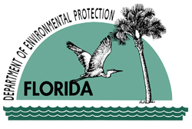Florida State Parks Monthly Newsletter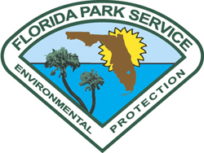
September 2007
The Department of Environmental Protection’s Florida State Parks are participating in International Coastal Cleanup events to collect debris in marine communities on Saturday, September 15th. The events are open to the public and provide an opportunity to help protect Florida beaches and coastlines. Visit www.FloridaStateParks.org and click on ‘Events’ to find a cleanup near you. | 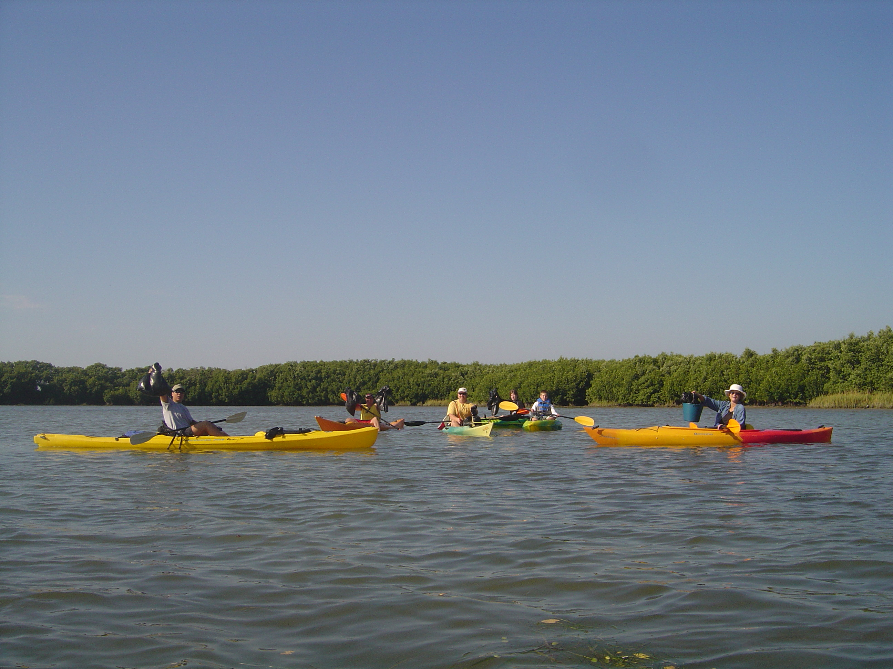  Coastal Cleanup Event 2006
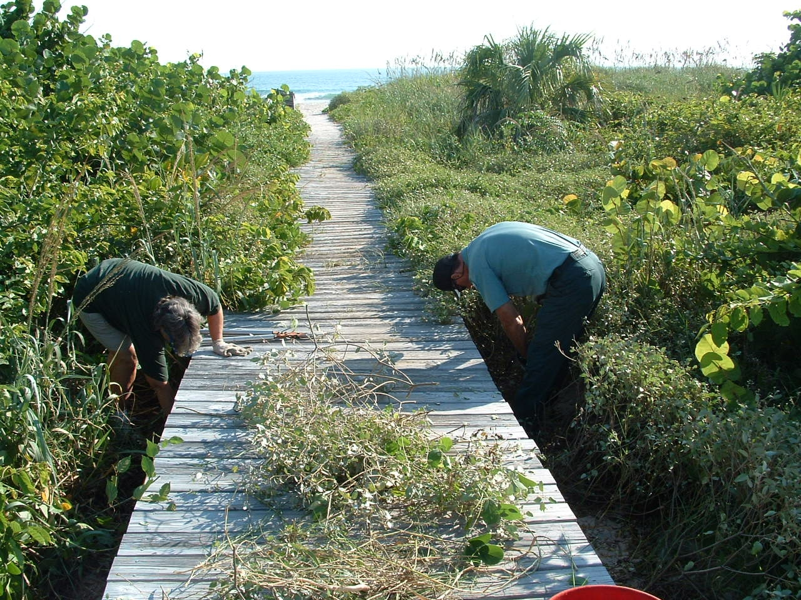  National Public Lands Day 2006 at Ft. Pierce Inlet State Park | In honor of state-owned lands and parks, Florida will be celebrating National Public Lands Day on Saturday, September 29th with events statewide. As a national leader in land conservation, Florida is recognizing National Public Lands Day across 161 state parks, thousands of miles of trails and millions of acres of conservation land. . Visit www.FloridaStateParks.org and click on ‘Events’ to find a National Public Lands Day event near you.
Free Admission to State Parks in September  With a Library Card  or  With a Library Book  or  With a Book Donation  Saturday, September 8th  is  International Literacy Day |   Visit www.FloridaStateParks.org to find out more about when parks are hosting their Coastal Cleanup, Public Lands Day, & Just Read, Florida! events…
Some of the upcoming Events at Florida State Parks
EVENING CRUISE AND DINNER
Edward Ball Wakulla Springs State Park
Date: Saturday, September 8 6pm – Dinner, Boat Tour 7:30pm
Description: Start with a delicious dinner at the historic Wakulla Springs Lodge, and then cuddle up with someone special as you cruise the scenic Wakulla River.
Fees: $29.00 Adult, $18.00 Children 12 and under-- Reservations Suggested.
Contact: (850) 224-5950
Directions: Traveling East on I-10 to new Exit 196 (old Exit 28). Take SR-263 (Capitol Circle) South 12 miles. Turn right (South) onto US-319/SR-61 (Crawfordville Hwy) for 2 miles. Bear left onto SR-61(Wakulla Springs Rd) for 6 miles. Turn left onto SR-267 at flashing stop light. Turn Right into Park entrance. From West I-10 use new Exit 203(old Exit 30). Take SR-61 (Thomasville Rd) South. Continue on SR-61 thru Tallahassee for 10 miles. Take US-319/SR-61 (Crawfordville Hwy) South for 2 miles. Bear left onto SR-61(Wakulla Springs Rd) for 6 miles. Turn left onto SR-267 at flashing stop light. Turn Right into Park entrance.
ANTIQUE CAR EXPO
Homosassa Springs Wildlife State Park
Date: Saturday, September 15, 2007. 10:00 a.m. until 4:00 p.m.
Description: The Friends of Homosassa Springs Wildlife Park present an Antique Car Expo on the green adjacent to the parking area at the park’s Visitor Center on U.S. 19. Most local car clubs will be participating and you will see muscle cars, Model A’s and Model T’s and street rods. Refreshment will be available.
Fees: $2.00 admission per person.
Contact: For more information, call 352-628-5343.
Directions: Homosassa Springs Wildlife State Park is located in Homosassa Springs, 75 miles north of Tampa on U.S. 19 and 90 miles northwest of Orlando.
OLD TIME DANCE
OLeno State Park
Date: Sunday, September 16, 2007. 4:00 p.m. until 7:00 p.m.
Description: Come out and join the fun!
Learn the steps to Circles, Squares and Contra dances that were all a rage in the mid 1800's when the town of Leno thrived! Dance to live music by the Flying Turtles String Band in the 1930's recreation hall on the banks of the Santa Fe River in O'Leno State Park. Located 6 miles north of High Springs on Hwy. 441.
Fees: Regular park admission plus Tickets: $5.00/adults, $3.00/child.
Contact: For more information call 386-454-1853.
Directions: O'Leno State Park is located on U.S. 441, six miles north of High Springs.
PAYNES PRAIRIE FILM, FORUM & EXPLORE SERIES
Paynes Prairie Preserve State Park
Date: Friday, September 21st. Doors open at 6:00 pm, film starts at 6:30 pm.
Description: Be transported as the film Water’s Journey: The Hidden Rivers of Florida traces the course of water through incredible underground liquid landscapes to places you can't even imagine water would go. Experience Florida’s most precious resource and learn what you can do to protect it. Come meet one of the filmmakers and bring your questions for our water partners.

Film & Forum Location: Paynes Prairie Visitor Center off Hwy 441 - 10 miles south of Gainesville - before Micanopy Click here for a map.

Fundraiser for Friends of Paynes Prairie: $5 per/person RSVP is greatly appreciated. Send an email or call 352-466-4100 (9 am to 4 pm).

Fees: Fundraiser for Friends of Paynes Prairie: $5 per/person.
Contact: For more information, call 352-466-4100.
Directions: Paynes Prairie Preserve State Park is located 10 miles south of Gainesville, in Micanopy, on the east side of US 441.
Coming from the north on I-75: Take exit 374, the Micanopy exit, and turn left at the end of the exit ramp. You will then be traveling east on CR 234. Stay on this road 1.4 miles until it intersects with US 441. Turn left onto 441 and go 0.6 miles to Paynes Prairie Preserve State Park (on the right).
Coming from the south on I-75: Take exit 374, the Micanopy exit, and turn right at the end of the exit ramp. You will then be traveling east on CR 234. Stay on this road 1.4 miles until it intersects with US 441. Turn left onto 441 and go about 0.6 miles to Paynes Prairie Preserve State Park (on the right).
MACARTHUR UNDER MOONLIGHT CONCERT
John D. MacArthur Beach State Park
Date: September 22, 7 - 9:00 PM
Description: Join us under the full moon for a magical night of music. This concert series will be held every month on the Friday or Saturday night nearest the full moon featuring a different band every month. Come on out and bring the whole family! No reservations required and children under age 10 are free.
Fees: Admission is $5.00. Children under 10 are free.
Contact: (561) 624-6952
Directions: John D. MacArthur Beach State Park is located 2.8 miles south of the intersection of U.S.1 and PGA Blvd. on A1A in North Palm Beach.
6TH MARION COUNTY SPRINGS FESTIVAL
Rainbow Springs State Park
Date: Saturday, September 22, 2007. 9:00 a.m. until 5:00 p.m.
Description: This year the Marion County Springs Festival will feature seminars with state and local freshwater spring’s experts giving updates on the health of Florida’s aquifer system, dozens of water conservation-oriented exhibits, live music, swimming in the Rainbow River, student art show, storytelling and more.
Educating Marion County residents and visitors about Florida’s freshwater springs is the goal of the 6th Marion County Springs Festival. Representatives from the Florida Springs Initiative, St. Johns River Water Management District, Southwest Florida Water Management District, Florida Geological Survey, Marion Soil & Water Conservation District, Marion County Planning Department and Wetland Solutions and others will be featured.
This year’s Festival will also offer a wide variety of educational and entertainment venues including a series of interactive booths on the Florida aquifer, water wise landscaping tips, arts and crafts vendors, food and beverage concessions, hiking in beautiful botanical gardens, a photography contest, live bands and a “Spring Song” contest.
Fees: Admission is $1.00 per person.
Contact: For more information, call 352-465-8555.
Directions: From I-75, exit at the second Ocala exit onto State Road 40. Take State Road 40, west. Drive until it dead-ends at U.S. 41. Turn left, the park entrance is on the left-hand side of the road. From Tampa, take U.S. 41, north. Drive through the town of Dunnellon. The park is located on the right-hand side of the road, approximately 2.5 miles north of Dunnellon. From areas in the northwest, take U.S. 41 to the town of Williston. After passing through Williston, you will come to a traffic light where State Road 40 has come to a dead-end. Go through this light; the park entrance is on the left-hand side of the road. The campground is separate from the headsprings day use area and is located 2.5 miles north of C.R. 484 off of S.W. 180th Avenue or 2.5 miles south of Highway 40 off of S.W. 180th Avenue.
BARNACLE UNDER MOONLIGHT - ALEX KASH
The Barnacle Historic State Park
Date: September 26, 6 - 9:00 PM
Description: Bring a picnic, bring your friends and come enjoy a lovely evening concert under the moonlight at The Barnacle. Alex’s music is described as a “combination of intense introspection, influenced by his Native American beliefs, Gospel greats, and the best of R&B and Folk.” No Pets. http://alexkash.com/
Fees: $5.00 - 10 years and older
Contact: (305) 442-6866
Directions: The Barnacle is located in Coconut Grove (Miami) at 3485 Main Highway.
KID'S BIRDING WORKSHOP
Faver-Dykes State Park
Date: September 29 2007, 8:30 a.m.-12:30 p.m.
Description: The Friends of Faver-Dykes State Park will be offering a Kid’s Birding Workshop. A Ranger and a member of the Audubon Society will illustrate some of the techniques birders use to observe and identify types of birds and the importance of conservation for their habitat. Participants will learn to identify song and wading bird species commonly seen in this area, and will learn how to use identification guides and binoculars. Each workshop will be hands-on with participants viewing along the banks of Pellicer Creek while applying their newly learned skills. Participants will also be constructing their own wooden bird house to take home with them. All gear will be furnished for each participant to use during the 4 hour workshop. Upon completion of the workshop each participant will be awarded a certificate of completion, a souvenir birding packet, and their very own newly constructed bird house to take home. Spaced are limited and advance registration is required by September 22nd.
Fees: $20.00
Contact: (386)446-6780 or Cristy.Leonard@dep.state.fl.us
Directions: Take Interstate 95 to exit #298 which is US 1. Go north on US 1 for 300 yards and turn right on Faver-Dykes Road. Go 1.5 miles on Faver-Dykes Road to Faver-Dykes State Park.
ST. JOHNS RIVER PADDLE BATTLE
Blue Spring State Park
Date: September 29, 2007, 7:00a.m.-2:00p.m.
Description: To celebrate National Public Lands Day we will conduct our 2nd Annual canoe/kayak race of three miles. In addition in addition our new partner TravelCountry.com will sponsor a more challenging 10 mile race. For more information or to download an entry form, click here.
Fees: $15-$25 depending on race and time of entry.
Contact: Contact park for more information.
Directions: Take exit 114 off Interstate 4 and follow the signs. Go south on 17/92 to Orange City, about 2.5 miles. Make a right onto West French Avenue.
OLD TIME DANCE
The Barnacle Historic State Park
Date: September 29, 6 - 10:00 PM
Description: Kick up your heels to traditional American music played by Mudhole Control and caller Warren Pollens while learning traditional American folk dance steps. Dances such as circles, squares, contras and waltzes were all the rage in the 1800s, so come dance like it’s 1891!
Fees: $8.00 - 10 years and older
Contact: (305) 442-6866
Directions: The Barnacle is located in Coconut Grove (Miami) at 3485 Main Highway.

