Setting up a Spatial Database Connection in ArcCatalog
- In order to set up a spatial database connection, you will want to first open ArcCatalog and look for “Database Connections”.
- Expand “Database Connections” and double click on “Add Spatial Database Connection”.
- A “Spatial Database Connection” window should pop up. You will want to make sure the fields match the image below. The username and password will be “sdeuser”.
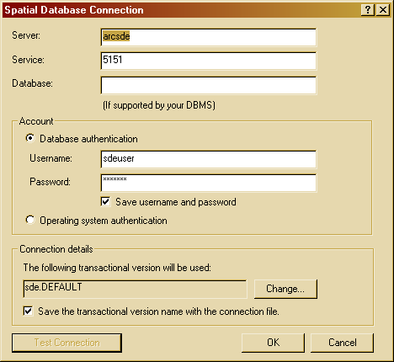
- Click on “Test Connection” on the bottom-right. Assuming the fields are correct, you should receive:
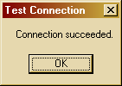

- Click “OK” and name the connection something that will be easy to remember. (Ex.” ArcSDE on 5151”)
- You can now access this connection by double-clicking on it at any time.

