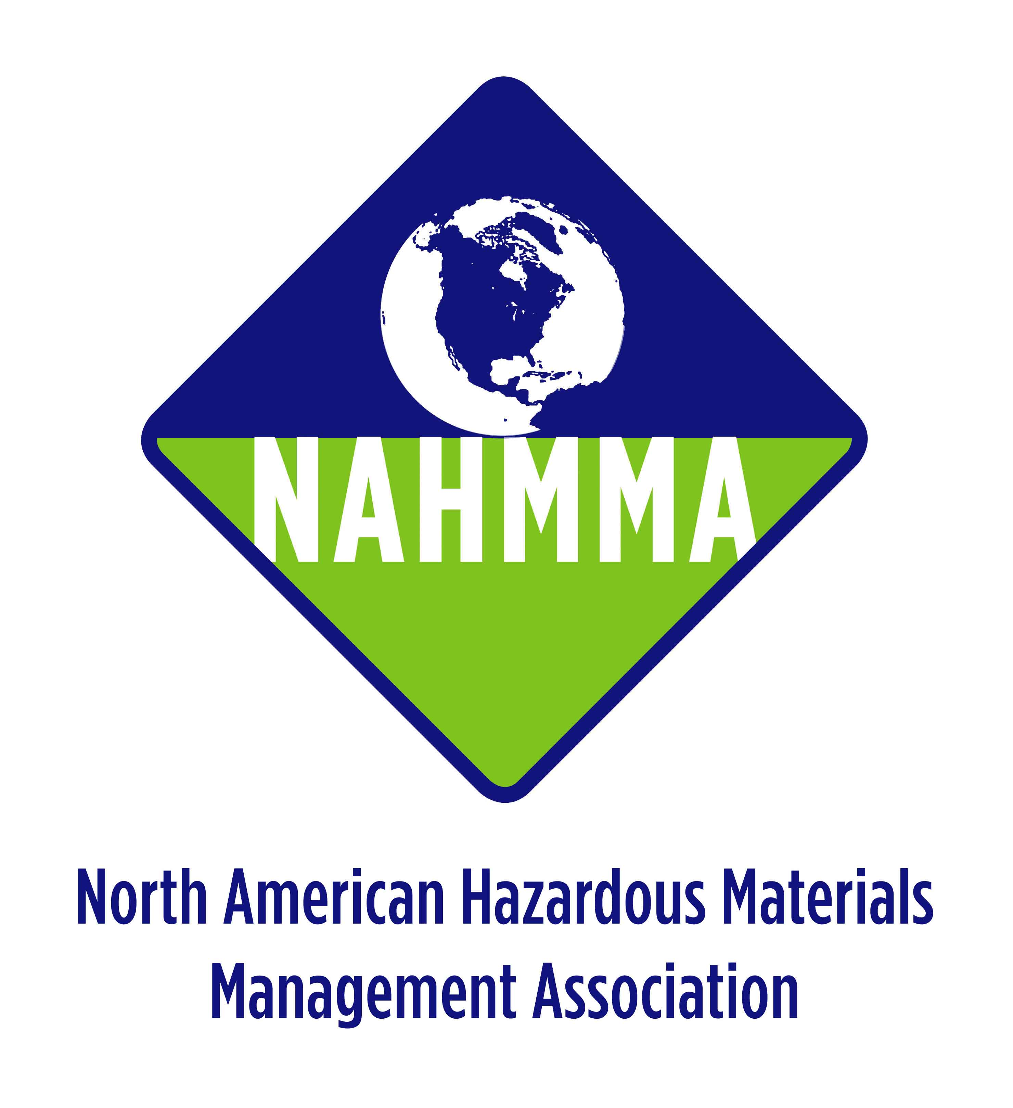
SAVE THE DATE
22nd Annual North American Hazardous Materials Management Conference
October 8-12, 2007
San Diego, California

“Solutions Within Reach: Programs and Policies for a Less Toxic World”

Join us for the 22nd Annual North American Hazardous Materials Management (NAHMMA) Conference this year in sunny San Diego, California from October 8-12. The conference will offer trainings and technical sessions, as well as facility tours and lots of opportunities to network with your peers.
Call For Papers
This year our conference theme is “Solutions Within Reach: Programs and Policies for a Less Toxic World.” With that in mind, we need your insight and creative ideas to ensure that these issues are addressed. You can contribute to the conference by submitting an abstract on a particular topic, or offering to moderate and prepare a full panel discussion on a topic close to your heart. The NAHMMA Program Committee is soliciting papers for the conference that may include any of the following:

- Universal Waste | - Electronic Waste
- Product Stewardship/ EPR | - Paints/solvents
- Pharmaceutical and medical waste | - Environmental justice
- Chemical policy initiatives | - Small business outreach
- Green Chemistry | - Toxicology and health issues
- HHW Facility Operations | - Global warming
- Pesticides | - Partnering with NGO’s and community organizations
- Zero waste policies | - Legislative and regulatory issues
- Environmental outreach/education | - Emerging waste streams
- Globalization of product labeling | - Procurement policies
- Used Oil Issues | - CESQG Programs

Proposed abstracts and sessions are not limited to these topics. We need to hear from you to make this a successful conference!
HOW TO SUBMIT A PAPER
Please submit your biographical sketch and brief abstract, describing your topic or session idea via email to Dee Johnson at paloma@well.com. All abstracts should include the general title and content – limited to 250 words or less. Include your name, agency information or affiliation, address, phone, fax and email address. The Program Committee will evaluate all proposals and respond by late April.

DUE DATE: ABSTRACTS DUE APRIL 20, 2007
SEND TO: Dee Johnson at paloma@well.com

