THE ATHENS DECLARATION as unanimously voted on August 3rd, 2007 at the 2nd International Conference on Environment in the City of Athens Cultural Center is as follows:

We, an international group, support the following six reasons to address citizen unused drug disposal:
1. To curtail childhood overdoses
2. To restrict household drug theft
3. To limit accumulation of drugs by the elderly
4. To protect our physical environment
5. To restrain improper international drug donations
6. To eliminate waste in the international health care systems of all countries

We call upon governments, NGO's, and citizens everywhere to correct policies and practices that foster waste in the health care systems of all countries and endanger humans, animals, and our physical environment.

We call upon all countries to renew their support of WHO Guidelines on Drug Donations and the WHO Guidelines on Drug Disposal, and strive to improve on these.

We call upon health care providers worldwide to appropriately prescribe medicines to patients in the most effective form and quantity.

We call upon health care organizations to refrain from policies that promote excessive dispensing.

We call upon patients worldwide to recognize the need for medicine to be effective it is to be taken as intended.

We call upon governments, NGO's, and citizens worldwide to refrain immediately from improper drug donations either as humanitarian aid following disasters or in general practice.

We call upon others to endorse these principles with us for the betterment of the health of the environment and patients worldwide.

Athens, Greece  August 3rd, 2007 | 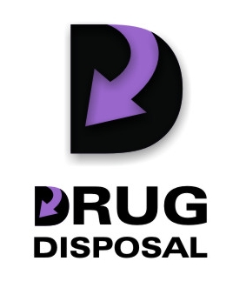 | In North America:  Maine Benzodiazepine Study Group  Stevan Gressitt, M.D.  207-441-0291  Gressitt@uninets.net  www.mainebenzo.org

