PHARMACEUTICAL DIALOGUE MEETING
SACRAMENTO, CA
June 19-20, 2008

Meeting Contact Information, and Hotel/Travel Logistics

Document version: June 13, 2008

MEETING LOCATION
The meeting will be held in Sacramento at the CA EPA Headquarters Building in downtown Sacramento. The dialogue will take place in the 1st Floor Training Room.

The Joe Serna Jr. Cal/EPA Headquarters Building
1001 I Street
P.O. Box 2815
Sacramento, CA
95812-2815

The building is 3 blocks from the Best Western Sutter House Hotel. Walk south on 11th Street toward Terminal Way. Turn right onto I Street. Walk one block and turn right at 10th Street. Enter the building through the main entrance.

Please allow for a few minutes to go through security; attendees will need to sign in and receive a name badge and visitor’s badge.

PSI CONTACT
If you have any questions, please contact:
Miriam Fuchs
(617) 236-4771
Miriam@productstewardship.us

HOTEL INFORMATION
We reserved a block of rooms at the Best Western Sutter House, but unfortunately there are no more rooms available at the negotiated rate. If you are still looking for a room, we recommend trying Expedia or some other search service to find a rate and location that works for you. There are several hotels in the vicinity of the meeting.

Best Western Sutter House
1100 H Street
Sacramento, CA 95814
(888) 256-8040
(916) 441-1314
www.thesutterhouse.com
-256-804
TRANSPORTATION
NOTE: I-5 Southbound will be closed June 13th through 26th
See attached web page: http://www.fixi5.com/pdf/us50STG2and4.pdf However, the J Street off ramp to the California EPA building is still open if coming from the airport. Taking J St. east will get you to the California EPA building.
The Sacramento International Airport is located 12.5 miles northwest of downtown Sacramento and about 20 minutes away from the Best Western Sutter Hotel. There are three ground transportation options:

- Super Shuttle is from the airport to the Best Western Sutter Hotel is available by calling (800) 258-3826. It costs $14.00 per person one-way and $28.00 round trip.
- Taxis are available in the ground transportation area of the airport for approximately $27.00 one-way to the downtown area and $55.00 round trip.
- There are also seven on-airport auto rental companies and the hotel offers complimentary parking.

INFORMAL DINNER ON WEDNESDAY JUNE 18TH
We invite you to join us for an informal dinner at a nearby restaurant on the evening of June 18th. Please meet us at the Pyramid Alehouse at 6:30 pm on Wednesday night.. The Pyramid Alehouse is located at 1029 K Street (see map below). If you will arrive in Sacramento in time to meet us down the street at the Pyramid Alehouse, please let us know when you register

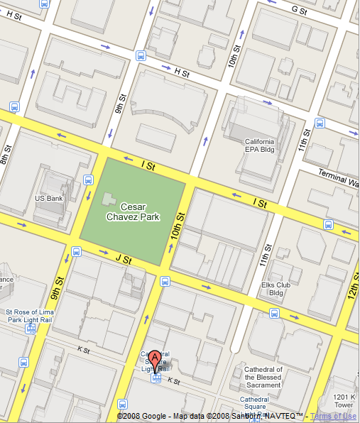

EVENING OF THURSDAY, JUNE 19TH
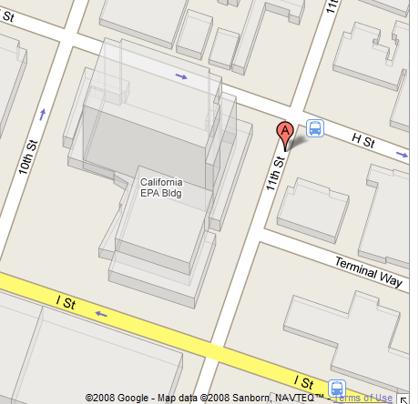
We invite you to join us across the street at Sofia Restaurant for a reception sponsored by Waste Management, Inc. on Thursday evening from 5:30-7:30 pm. Sofia Restaurant is located at 815 11th Street (see below).

