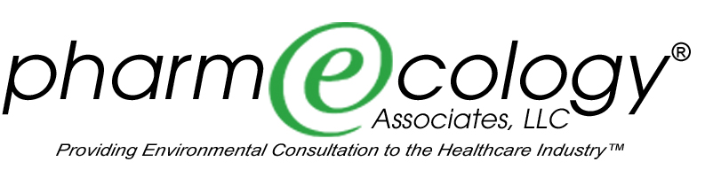

Consumer Drug Take-Back Resources

Many different models are currently being explored to facilitate the disposal of unwanted and expired drug products being generated by consumers in their homes. The greatest obstacle to an easy and cost-effective program is the requirement that a law enforcement officer be present to receive any controlled substances. The following list should be used as a starting point. New programs are being developed constantly. The DEA is developing regulatory changes that may provide some relief in the future.

The following sources may be useful as you develop your consumer drug take-back program.

1. Pharmaceutical Take-Back Case Studies – Models of Success
Download this PDF by the Illinois Indiana Sea Grant Program at http://www.iisgcp.org/unwantedmeds/updatedToolkitMaterials/2.0CaseStudies.pdf and http://www.wmrc.uiuc.edu/special_projects/ppcp-env/1315-Boehme.ppt#459,9,Slide 9

2. Contact the following for a list of consumer take-back programs in development:
Community Medical Foundation for Patient Safety, 6800 West Loop South, Suite 190
Bellaire, TX 77401, www.comofcom.com, Fax: 832-778-7777

3. Mail-back Program through Reverse Distributor: http://www.reuters.com/article/pressRelease/idUS241303+08-May-2008+PRN20080508

3. Join the pharmwaste listserve, which regularly features items of interest regarding consumer takeback:
To join the list serve, please go to this address and follow the directions:
http://lists.dep.state.fl.us/cgi-bin/mailman/listinfo/pharmwaste

4. California program No Drugs Down the Drain information available at http://www.nodrugsdownthedrain.org/.

5. Northwest Product Stewardship Council information on innovative pharmacy-based take-back program available at: http://www.productstewardship.net/productsPharmaceuticalsActivities.html

6. For information on your state or region, google your state plus consumer drug take-back. Many programs are developing and can be searched in this manner.

