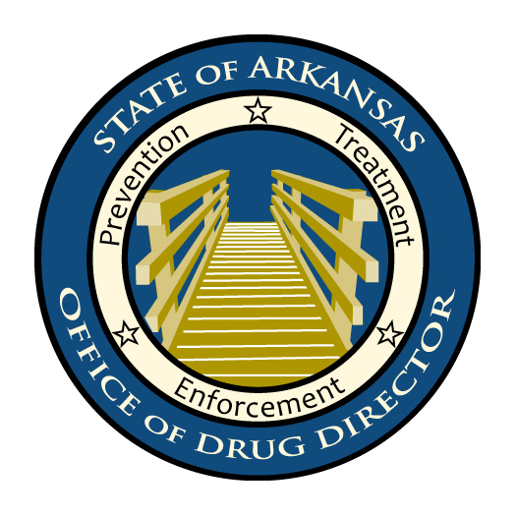
Office of the Drug Director

FOR IMMEDIATE RELEASE
Contact: Steve Varady, 501-618-8693
___________________________________________________________________________

ARKANSAS TO LAUNCH YOUTH PRESCRIPTION DRUG ABUSE PREVENTION CAMPAIGN

Little Rock, Arkansas, February 19, 2010 –

The diversion and abuse of prescription drugs pose a major challenge to health care providers, substance abuse treatment providers, prevention officials, law enforcement, schools, communities, and parents. Abuse by teenagers in Arkansas is particularly concerning. According to the most recent Arkansas Prevention Needs Assessment, a survey designed to measure drug abuse among Arkansas youth, close to one-fourth of responding high school seniors have abused pharmaceutical drugs at least once in their lifetime and approximately 10% had engaged in recreational use in the past thirty days. In past national studies, Arkansas has ranked first in non-medical use of prescription pain relievers. And nationally, for the first time, teens are reporting that it is easier to obtain prescription drugs than beer.

“Prescription drug abuse is growing exponentially,” said Dr. John Kirtley of the Arkansas State Board of Pharmacy. “Part of this is due to the assumption that prescription medications are 'safe and effective' since they are approved by the FDA. Unfortunately, most young people do not think about or realize the risks associated with misuse and abuse. When prescription medications are not used according to precise instructions and with appropriate oversight by medical professionals, the risk of side effects, addiction and even death are greatly multiplied.”

In an effort to curb prescription drug abuse by Arkansas teens, a collaborative media, education, and law enforcement prevention campaign is set to begin statewide on March 8. Because most teens are freely provided with or steal these drugs from parents, grandparents, or friends, the campaign is designed to provide key information on how to properly monitor, secure, and dispose of commonly abused and other medicines and to raise awareness of teen prescription drug abuse.

“It’s crucial that we take preventative measures,” said Fran Flener, Arkansas Drug Director. “We need to treat our medications as we would fine jewelry or a loaded gun. There are so many things parents can do to prevent their kids from having these problems, starting with controlling their own medications. The most important resource a child has in deciding to be drug-free is his or her parents.”

Dr. Kirtley added, “It is vital to help people increase awareness regarding what medications they have in their homes, inform them how to secure their medications, and inform them how to appropriately dispose of their medications when they are no longer needed. These three steps could help prevent countless problems and potential injuries or death from prescription drug abuse.”

Components of the campaign will include:
- Statewide broadcast and print advertising emphasizing the safe control of pharmaceutical drugs.
- Statewide television, radio, and print news coverage.
- Prescription drug abuse prevention website, www.ioit2me.com, including training materials which may be tailored for community training needs.
- Coordinated community awareness events located in Arkansas Prevention Resource Center regions.
- Coordinated community drug take-back events sponsored by local Arkansas Law Enforcement Agencies and Prevention Resource Centers.
- Dissemination of a community drug take-back event planning toolkit to all Arkansas Law Enforcement Agencies.
- Targeted messages on prescription information sheets for commonly abused drugs distributed in Arkansas pharmacies.
- Public release of Division of Behavioral Health Services and Pride Surveys’ “Special Report on Over-the-Counter and Prescription Drug Use among Arkansas Students”.

The campaign is being delivered through the efforts of the Arkansas Drug Director’s Office, the Attorney General’s Office, the U.S. Attorney’s Office, the Department of Human Services, Office on Alcohol and Drug Abuse Prevention, State Prevention Resource Centers, the Arkansas Sheriffs’ Association, the Arkansas Association of Chiefs of Police, the Arkansas State Police, the Drug Enforcement Administration, the Arkansas State Crime Laboratory, the Benton Police Department, the Arkansas Pharmacists Association, the Arkansas State Board of Pharmacy, the Arkansas Chapter of the American Academy of Family Physicians, the Arkansas Osteopathic Medical Association, the Pharmaceutical Research and Manufacturers of America, the Arkansas Behavioral Health Providers’ Association, Maloney Marketing, ARKOMA Consulting, the Arkansas Crime Information Center, the Arkansas National Guard, Out of the Dark, Inc., One Day at a Time, Inc., the University of Arkansas Cooperative Extension Service, the University of Arkansas Criminal Justice Institute, Walmart Stores, and a host of additional agencies and individuals.

###

