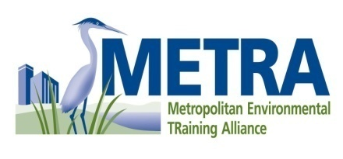

CORDIALLY INVITES YOU TO ATTEND:
ENVIRONMENTAL TRAINING FOR THE MEDICAL INDUSTRY
WHERE: Leu Gardens (leugardens.org)
Orlando FL
WHEN: December 9, 2010, 8:00-noon
WHY: To understand environmental regulations
FOR THE LOW COST OF: $15.00
Register at METRA.org
Pharmaceutical
Waste
Hazardous
Waste
By December 2, 2010

