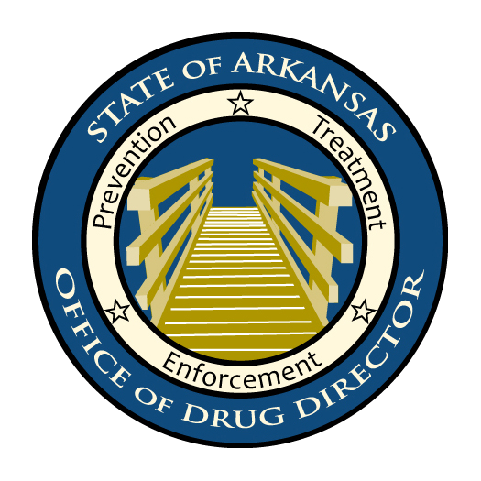

Take-Back Resources

http://www.youtube.com/watch?v=rOrmJmRhoB8
- YouTube link to “We Have a Problem” video made possible by Arkansas Rotary Organization and produced by Carolyn Long, Lance Herring, and Jones TV.

http://www.artakeback.org/
- State Take-Back website – information for general public; includes April 30 pill collection sites and educational material for public.
- We would like this site linked to as many other organization’s websites or emailed / “ListServed” to as many as possible.
- We would like this site mentioned in all local news coverage as a means to promote statewide event

https://ardhs.sharepointsite.net/RX/default.aspx
- Prescription coalition/take-back committee
- Contains flyers, press releases, educational materials, presentations, drug ID booklet, DEA information, and many other resources for Monitor, Secure, Dispose campaign, and both September 25 and April 30 DEA / Arkansas Take Back.
- Materials on this site are available for download, use, and sharing to any entity or organization who would like them at
- Direct link to materials: https://ardhs.sharepointsite.net/RX/Shared%20Documents/Forms/AllItems.aspx

http://www.deadiversion.usdoj.gov/drug_disposal/takeback/index.html
- DEA national take-back website
- Direct link to DEA national “find a site”:
https://www.deadiversion.usdoj.gov/NTBI/NTBI-PUB.pub;jsessionid=109396C4B44A669C9B5F5566DC24E4AF?_flowExecutionKey=_cB5168420-C4CF-69F5-D988-5737D0846D8D_k4A216140-083B-7FF5-6ABC-36FB3D7EA7CC

