SAVE THE DATE!
2011 International Symposium on Safe Medicine*

*Previously known as the International Symposium on Pharmaceuticals in the Home and Environment

Sunday - Tuesday
October 2-4, 2011

Holiday Inn by the Bay Hotel & Convention Center
Portland, Maine

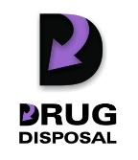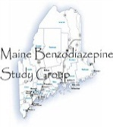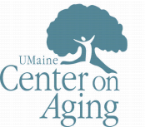

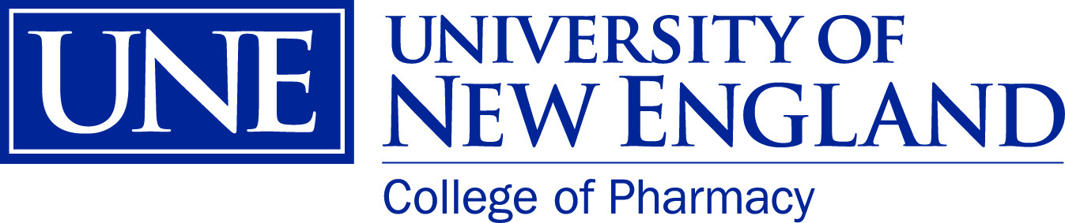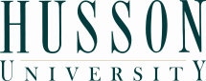



This conference is designed for medical, health, pharmaceutical, and human service practitioners, educators, policymakers, law enforcement personnel, environmentalists, substance abuse professionals, and others concerned with the human and environmental impact of prescription drugs on individuals and their external environment. This year’s program addresses the full range of issues surrounding: 1) the environmental and social impact of unused prescription drugs stored in homes and flushed or otherwise discarded into the environment; 2) innovative return and disposal policy and program responses and related environmental issues; 3) the multitude of issues surrounding the use, misuse, and abuse of prescription drugs with a special focus on benzodiazepines, a class of medications used to treat anxiety, stress, and insomnia; and 4) pertinent health, safety, and improved medication prescribing practices and policies.

Registration Information Available Later This Summer

For more information about registering contact:
Kelly Alden
kalden@une.edu
Conference Manager
University of New England
716 Stevens Ave.
Portland, ME 04103
(t) 207-602-2137
(c) 207-468-3345
(f) 207-221-4988

