June 1, 2011

Name & Address:

Dear:

On behalf of this year’s Executive Planning Committee I am very pleased to invite you to be a plenary presenter at the 2011 International Symposium on Safe Medicine. This conference will be held on Monday and Tuesday, October 3-4, 2011 in Portland, Maine at the Holiday Inn by the Bay Hotel and Convention Center.

This year’s Symposium is being organized by the Maine Benzodiazepine Study Group, the Drug Disposal Group, the University of New England College/of Pharmacy, Husson University/ School of Pharmacy, and the University of Maine Center on Aging.
The conference will have multiple focal points including the promotion of better prescribing practices, reducing drug diversion, medication risk assessment, and safe and environmentally sound drug return protocols for unused and expired medications that often accumulate in the medicine cabinets of consumers. This special event will provide a forum where research will be disseminated, policy developments discussed, and collaborative multidisciplinary relationships forged to address these pressing issues. Last year’s conference drew approximately 175 participants representing some 25 states throughout the country.

I am hopeful that your schedule will allow you to participate in this much anticipated conference.

As soon as you are able, I would appreciate you notifying me of your interest and availability to participate. We would also want to determine as soon as possible what day and time will work best for you in terms of scheduling your presentation. I can be reached at 207-441-0291 or at gressitt@gmail.com should you have any questions.

Sincerely,

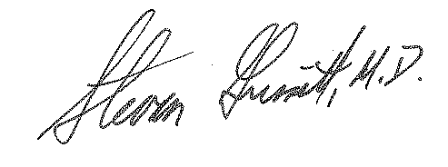
Stevan Gressitt, M.D. John V. Schloss
Founding Director, University of New England
Maine Institute for Medicine Safety Chair, Pharmaceutical Sciences

