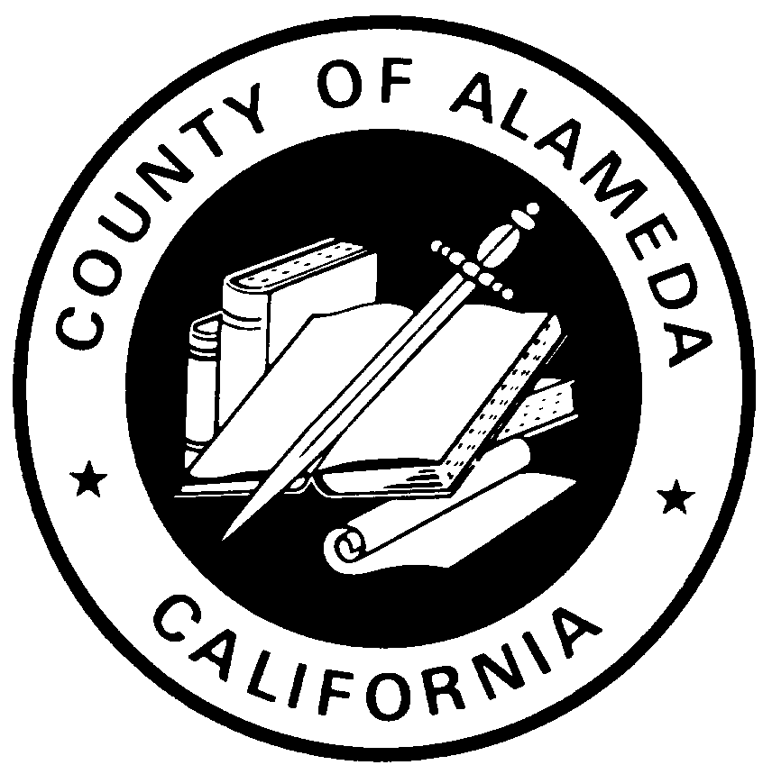
Board of Supervisors

Nathan A. Miley, President
Supervisor, District 4

Oakland Office Eden Area District Office
1221 Oak Street, Suite 536 20993 Redwood Road
Oakland, CA 94612 Castro Valley, CA 94546
510-272-6694/510-465-7628 Facsimile 510-670-5717/510-537-7289 Facsimile

district4@acgov.org
January 27, 2012

Dear Friends,

Last October, my office hosted a Safe Medication Disposal Conference in partnership with the Senior Alcohol and Other Drug (AOD) Prevention Workgroup. The conference was a great success and the first of its kind in Alameda County to address the need for safe and convenient disposal of medication waste and prevent discarded drugs from entering our waterways and landfills.

The day-long event was well attended with dozen speakers, including: Nancy O'Malley, Alameda County District Attorney; Greg Ahern, Alameda County Sheriff's Department; and Alex Briscoe, Director of the Alameda County Healthcare Services Agency. The group discussed solutions for implementing a product stewardship program for the safe disposal of unwanted drugs.

Since then, we have continued our work and drafted a proposed County-wide Safe Drug Disposal Ordinance, which you will find attached to this email. It includes a product stewardship plan for collection and disposal of unwanted drugs from residential sources as well as recommendations for implementation, enforcement, fees and penalties. This groundbreaking policy will hold producers responsible for disposal of unwanted drugs and reduce the number of accidental deaths caused by poisoning among older adults from overdoses of over-the-counter, prescription and illicit drugs. In addition, a safe medication disposal program would decrease access and availability of drugs to youth of all ages.

As key stakeholders, I am reaching out to ask for your support for the proposed ordinance. If you can please write a letter of support endorsing this policy and send it to my office by February 15, I would greatly appreciate it. In addition, you are invited to attend the Alameda County Board of Supervisors meeting February 28, at 10:30 a.m. and I encourage you to voice your support for the proposed ordinance during the public comment period. The meeting will be held at Administration Building, Board Chambers 1221 Oak Street, Oakland CA 5th Floor Rm. 512.

Thank you again for your attention to this important matter. I strongly urge you to support a County-wide Safe Medication Disposal Ordinance that will protect all of our residents and the environment.

Sincerely,

Nate Miley

