Rationale for a Concerted Focus on Unused Pharmaceuticals
Ilene S. Ruhoy, MD
Doctoral Candidate
University of Nevada, Las Vegas
Department of Environmental Studies
Stevan Gressitt, MD
Maine Benzodiazepine Study Group, The Drug Disposal Group,
Medical Director, Northeast Occupational Exchange,
Corresponding Author: 314 Clark Road, Unity, Maine, 04988 207-441-0291 gressitt@uninets.net
2nd INTERNATIONAL SYMPOSIUM ON ENVIRONMENT

August 2-3, 2007, Athens, Greece
Abstract:
Unused and unwanted consumer pharmaceuticals have a negative impact on public health. The lack of effective and efficient methods of drug disposal has resulted in unwelcome social, cultural, ecological, and global effects.
Among the many issues pertinent to unused consumer medication, we have comprehensively explored and addressed six specific and significant problems;
- Childhood Poisoning: Unintentional pharmaceutical poisonings of children, resulting in unnecessary morbidity and mortality.
- "Pharming": Theft and social use, misuse, and abuse of pharmaceuticals by teenagers, adults, and older adults.
- Excessive Accumulation and Polypharmacy: Polypharmacy, non-compliance and/or poor adherence to medication regimens, and medication errors contributes to accumulation and poor patient outcome.
- Unintended Environmental Exposure: Potential deleterious effects on wildlife and humans due to drug deposition in surface and ground waters as a result of both disposal and excretion pathways.
- Inappropriate Humanitarian Drug Donations: Under-regulated and poorly controlled methods of international donations to countries in need, resulting in massive amounts of “gifts” of unused and expired pharmaceuticals. Expired and unwanted drugs ultimately become accumulated waste, some of which may be hazardous, due in part to the lack of an environmentally sound disposal or destruction method.
- Pharmacoeconomics: Unused medications contribute to wasted health care dollars. The purchase costs of drugs to the consumer, the insurance carrier, and the taxpayer have continued to increase in the past decade.

These issues define the problem of proper disposal of unused pharmaceuticals and beg for acceptable solutions to protect human and environmental health.

Q1, Greatest Threat (Pharmaceuticals)
 | Maine | NE | US
2003 | 21.5 | 3 | 2.4
2004 | 30.7 | 4.9 | 3.1
2005 | 31.2 | 5.2 | 3.9
2006 | 32.9 | 9.3 | 3.9
(NDIC 2006 Drug Threat Assessment, Gressitt)

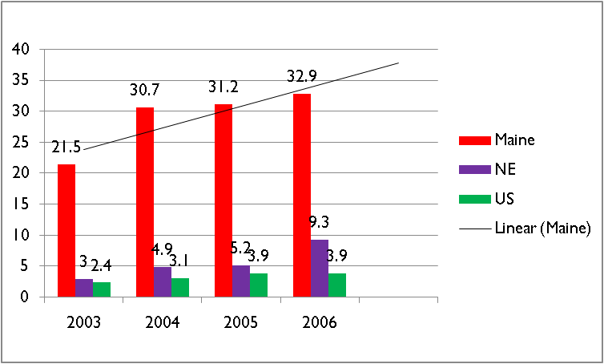

 | 2002 | 2003 | 2004 | 2005
Prescription Narcotics
Individuals (12 and older) | 4.7 | 4.9 | 4.7 | 4.9
Adolescents (12-17) | 7.6 | 7.7 | 7.4 | 6.9
Adults (18-25) | 11.4 | 12 | 11.9 | 12.4
Adults (26 and older) | 3.1 | 3.3 | 3 | Trends in Percentage of Past Year Drug Use, 2002-2005  National Drug Intelligence Center, 2005  3.3

 | 2002 | 2003 | 2004 | 2005
Prescription Narcotics
8th Grade | NA | NA | NA | NA
10th Grade | NA | NA | NA | NA
12th Grade | 7 | 6.7 | 9.4 | 9.3
Sedatives/Barbiturates
8th Grade | NA | NA | NA | NA
10th Grade  Adolescent Trends in Percentage of Past Year Drug Use, 2000-2005  National Drug Intelligence Center, 2005  NA | NA | NA | NA
12th Grade | 6.2 | 5.7 | 6.7 | 6
Tranquilizers
8th Grade | NA | NA | NA | NA
10th Grade | NA | NA | NA | NA
12th Grade | 5.7 | 6.9 | 7.7 | 6.7

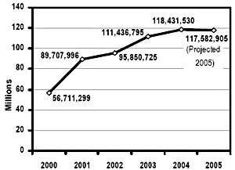 Source: National Drug Intelligence Center, 2005

http://www.mainebenzo.org/
