Exercise

Cad Drawing Transformation

In your personal trainingdata folder find the NorthLogan folder containing the northlogan-h20.dwg file (a cad drawing of under-street water lines) and the northlogan-rds.shp is a line shape file of streets in the area.

Your task is to transform the cad drawing of unknown coordinates to ‘fit’ the streets data which are in UTM projection.

STEP 1 Add data to an ArcMap Session

Start an ArcMap session and add the northlogan-rds.shp line shape file to a data view, and then add the northlogan-h20.dwg file. You will notice that there are two version of the .dwg file, one icon is blue, while the other is white. By double clicking on the blue icon, you are presented with an additional add data box; select the polyline.

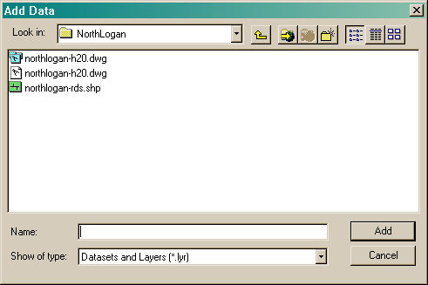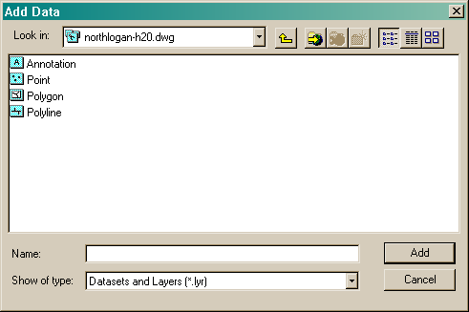

At this point neither feature sets line up due to the fact that they have nothing coincident in a spatial context, other than we know they do. Right click on each feature set individually, and select zoom to layer. Get familiar with what lines have similar geometry. Look for similar intersections and recognizable bends, shapes etc. Obviously, you will need to over look the lines of the cad drawing that outline the drawing itself, text boxes, and other non-essentials. Your data view while zoomed to the cad drawing will look something like this:

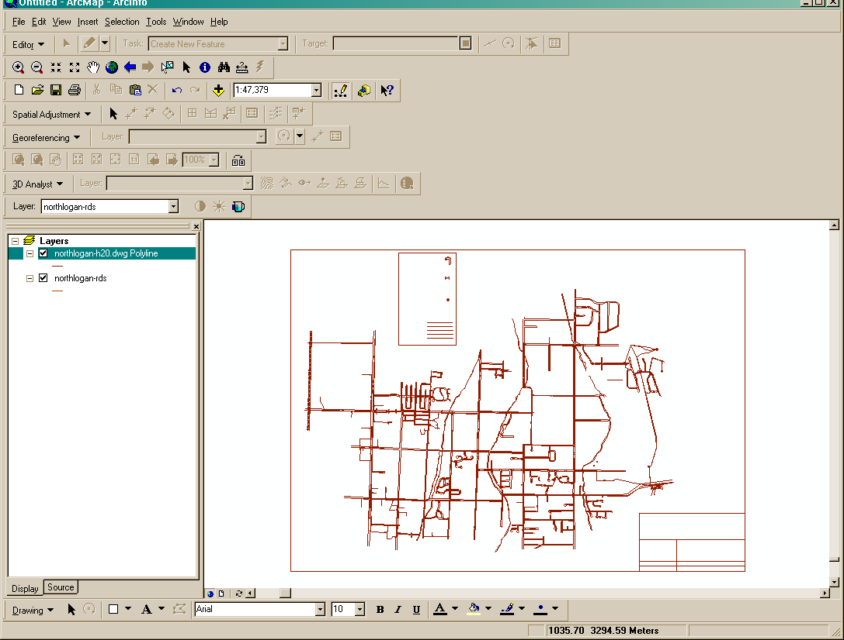

STEP 2 Obtain the transform from-to points

Now that you are familiar with the area, you need to record specific coordinates values of locations common to the drawing and the roads shape file. While zoomed to the cad drawing, use the zoom tool to zoom in closer to one of the intersections you plan use as a control point. Place the cursor of that inter section, and jot down the X and Y values shown in the indicator box at the lower right border of the ArcMap application window.

Once recorded, right click on the roads shape file and select zoom to layer. Again using the zoom tool, zoom in closer to the intersection that is coincident with the one you chose in the drawing. Placing the cursor over the intersection, jot down the coordinate values as you did before. You will notice that these values are now in real-world, UTM values.

Repeat this process for a second intersection, obtaining first the cad coordinates, followed by the shape file coordinates.

STEP 3 Set the transformation

Right click on the cad drawing and select properties. In the Layer Properties sheet, select the Transformations tab. Check Enable Transformations and under Transform By, switch to Coordinates. Referring to your notes taken in step 2, enter the appropriate coordinate values in the From and To boxes provided.

Just prior to hitting the Apply button, your Layer Properties sheet, Transformation Tab should look like this:

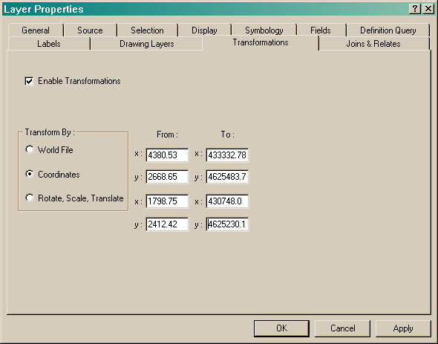

Click on the apply button and then close the Layer Properties sheet. As if by magic, the cad drawing has been geometrically transformed to the roads. At this point, the transformation is for this session only, however, if you need to or would like to, you can convert the Cad drawing to a shape file by right clicking on it, pulling down to Data and then selecting Export. Give it a path and shape file name, and be sure to select ‘Use the same Coordinate System as the data frame’.

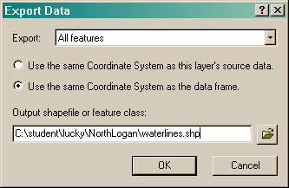

The question lingers, ‘Why would I want to convert this to a shape file?’ One answer may be, if you want to use the data repeatedly in an ArcGIS setting for mapping and or presentation purposes you would. As a shape file you then have the ability to edit out the extraneous features, like the text box outlines so the just the data appears. Additionally, you can add real data to the attributes table of the shape file. In the waterline data example used in this lab, you could add line sizes, material types, etc.

STEP 4 Create a World File

A world file is a small text file that contains transformation coordinates, just like what you entered in to the Layers Property, Transformation tab. You can easily create a world file for the northlogan-h20.dwg file by opening a text editor (like WordPad) entering in the cad x y coordinates followed by the corresponding ‘real-world’ coordinates. The cad coordinate pair and the real-world coordinate pair are comma separated, but the sets of pairs are space separated (Cad-X,Cad-Y Real-X,Real-Y). Save the file with the same file name as the cad drawing, in the same directory, but with a wld (short for world) extension. The file will look like this:

4380.53,2668.65 433332.78,4625483.71

Save it as northlogan-h20.wld in the NorthLogan directory. Going back to your ArcMap session, remove the transformed version of the cad drawing, and re-add it now that you have created a world file for it. You will notice that it comes in transformed to the roads data. This technique will allow you to use the cad drawing as such in an ArcMap setting without changing it to a shape file.

You can close down your ArcMap session as this ends the exercise.

