Geospatial Bootcamp!!!
Offered by KTG, LLC

December 18-19
0730 - 1700
Drill Sergeant: Katherine Milla, GISP

This two-day basic training will put you through your paces.
During this class we will touch on a broad spectrum of digital geospatial applications, including: use of web-enabled map sites and software; ArcView GIS applications; collecting, downloading and plotting GPS data; and use of free and low-cost software alternatives to ArcView.
Requirements: All trainees MUST bring a basic knowledge of Microsoft Windows and her/his own Windows PC laptop with wireless or LAN capability (bring your cable!). Course fees include a standard issue tutorial workbook, tutorial textbook, evaluation copy of ArcView GIS, a data disk and morning refreshments (lunch is on your own). For this course you will install the evaluation software on your own laptop. While time will be spent at the beginning of the course loading the software, it’s best to register and pick up your workbook and install software in advance to avoid potential problems or delays at class time.
Cost: Two full days of training plus materials for the low, low price of $150.00

Now for the Fine Print:
At this time, only checks or money orders can be accepted. We hope to be able to process purchase orders soon. Please make checks payable to KTG, LLC. Payment must be made in full prior to the course. Registrations not received by Monday December 10th cannot be guaranteed a seat. Cancellations made after December 10th will receive a 50% refund. Course may be cancelled if fewer than eight (8) students register. Cancelled class tuition will be refunded in full.

If you are willing to accept this challenge, fill out the application below and mail with, along with full payment, to:

KTG, LLC
1545 Heechee Nene
Tallahasssee, FL 32301

email: kmilla@ ktg-geospatial.com
850-345-7505
www.ktg-geospatial.com

Location: Hampton Inn and Suites, 3388 Lonnbladh Rd, Tallahassee, FL 32308.
850-574-4900.

Time: 7:30 AM – 5:00 PM
Registration Information
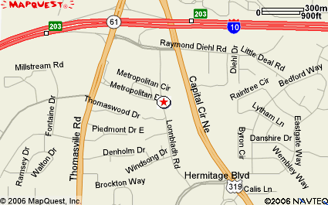

Student Name:
________________________________

Company:
________________________________

Address: ________________________________

City: ____________________________

State: ___________________________

Zip: _____________________________

Phone: ___________________________

Fax: _____________________________

email: ___________________________

So we may tailor your basic training needs, to your particular combat situation, please answer the following questions:

Reason for taking this course:

Please describe your level of experience with geospatial technologies (e.g. software, web
applications, GPS …) (No geospatial experience required for this course)

Please describe any specific areas you would like to see covered in this course.

