Geospatial Bootcamp!
New Expanded Offering!
Offered by KTG, LLC

March 10-12
0800 - 1700
Drill Sergeant: Katherine Milla, PhD, GISP

During this three-day basic training course you will learn a comprehensive set of basic skills for digital geospatial applications, including: use of web-enabled map sites and software; ArcView GIS applications; collecting, downloading and plotting GPS data; where and how to obtain existing geospataial data; image acquisition and rectification (see class schedule below).

Requirements: All trainees MUST bring a basic knowledge of Microsoft Windows and her/his own Windows PC laptop with wireless or LAN capability (bring your cable!). Course fees include a tutorial textbook with a fully functional six-month evaluation version of ArcView, a tutorial workbook, and a data disk. Morning coffee will be provided (lunch is on your own). For this course you will install the evaluation software on your own laptop. While time will be spent at the beginning of the course loading the software, it’s best to register and pick up your workbook and install the software in advance to avoid potential problems or delays at class time.

Cost: Three full days of training plus materials for the low, low price of $400.00!!!

Now for the Fine Print:
Payment can be made by check, MasterCard or Visa. Please make checks payable to KTG, LLC. Payment must be made in full prior to the course. Cancellations made after March 2nd will receive a 50% refund (registrations can be transferred to another person). Course may be cancelled if fewer than five (5) students register. Cancelled class tuition will be refunded in full.

If you are willing to accept this challenge, fill out the application below and mail, along with full payment, to:

KTG, LLC
1545 Heechee Nene
Tallahasssee, FL 32301

email: kmilla@ ktg-geospatial.com
850-345-7505
www.ktg-geospatial.com

Registration Information

Student Name:
________________________________

Company:
________________________________

Address:
________________________________

City: ____________________________

State: ___________________________
Zip: _____________________________

Phone: ___________________________

Fax: _____________________________

email: ___________________________

Method of Payment:

Check ___ MasterCard ___ Visa ___
If paying by credit card please provide the following information:
Account # ________________________
Expiration Date ____________________
Billing Name and Address:

If you prefer you may provide this information by phone.

So we may tailor your basic training to your particular needs, please answer the following questions:

Reason for taking this course:

Please describe your level of experience with geospatial technologies (e.g. software, web
applications, GPS …) (No geospatial experience required for this course)

Please describe any specific areas you would like to see covered in this course.

Geospatial Bootcamp Class Schedule
March 10-12

Location: Hampton Inn and Suites, 3388 Lonnbladh Rd, Tallahassee, FL 32308. 850-574-4900.
Time: 8:00 AM – 5:00 PM

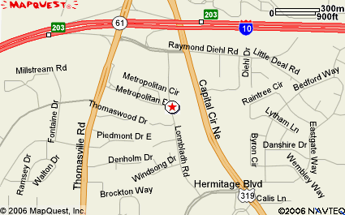

Day 1: (Meet at 7:30 to install software)

Install software

GIS is everywhere. Web-enabled apps: Florida CHARTS exercise

Test drive ArcView: Exercise 1 in GIS Tutorial

Lecture: vectors and rasters and tables, oh my!

Exercise: Create event theme from hurricane tracking coordinates, convert to shapefile
Map projections lecture

Exercise: Working with Census data and map projections.

Tables-querying, linking, add fields

Tables exercise: download and work with data from USDA National Agricultural Statistics Service Census of Agriculture.

Order imagery online for day 3

Day 2

Working with GPS data, lecture

GPS exercise: Collect GPS data, plot in ArcView

Lecture DMS vs DD: how to plot coordinates

Exercise: Download image data from LABINS

Exercise: Create data attributes: add fields to GPS points

Day 3 Working with Imagery

Lecture on imagery: aerial photographs, DOQQs, satellite images

Learn where to obtain imagery for Florida

Exercise: Working with images, georeferencing

Exercise: Create new shapefiles, “heads up” digitizing

