How to Add Picture Links to Shapefiles\GPS Points

- Create “PICTURES” field in the attribute table of the shapefile\GPS points that you want linked to the pictures.
  - Make sure that this field is a TEXT field.
  - Make the length of the field “150” to ensure that you have space for the hyperlink text.

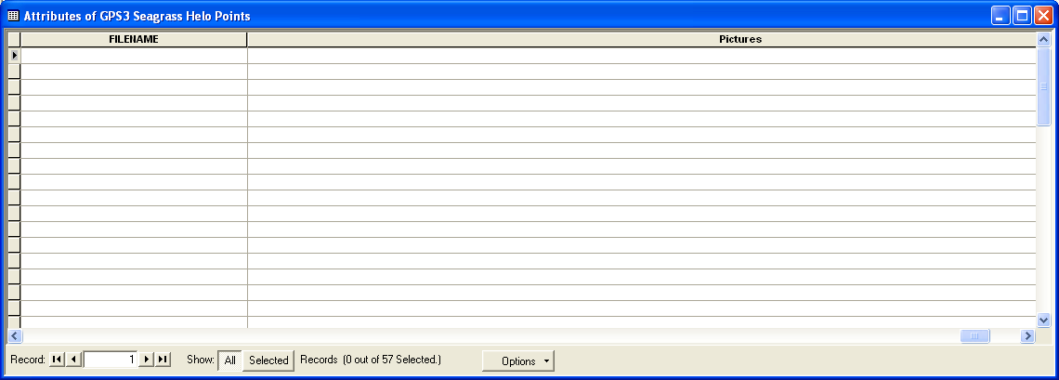

- Start the Editor on the shapefile\GPS points that you have added the PICTURES field to.

- Add the full text location of the picture location (i.e. S:\BES Shared Drive\10-1 PROJECTS – ACTIVE\Picture xxx.xxx).

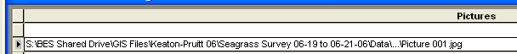

- Stop the Editor and save the edits on the attribute table.

- Go into the properties of the shapefile\GPS points that you have edited and click on the DISPLAY tab.

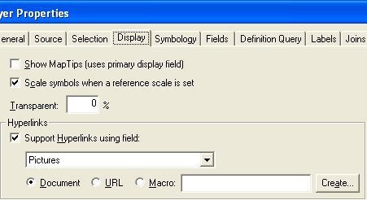

- Put a check in the “Support Hyperlink using field:” checkbox.
  - After doing this, select your PICTURES field from the drop-down selection box.

- Click OK.

- On the far right-hand side of the Tools toolbar, select the HYPERLINK button.

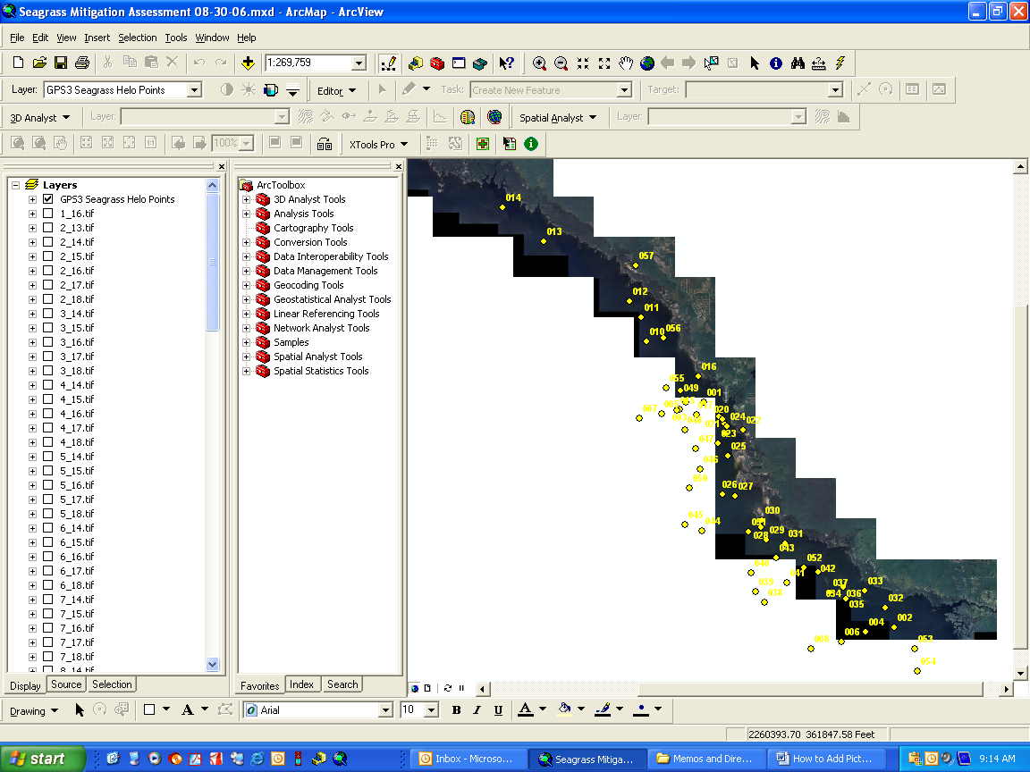

- Move your mouse over the shapefile\GPS points that you have linked the picture to.
  - The mouse will change to a dark color when you are on the active link
  - Click the mouse button to open the picture that is linked.

