ArcGIS Online Service

User Name: arcgis_beta
Password: beta

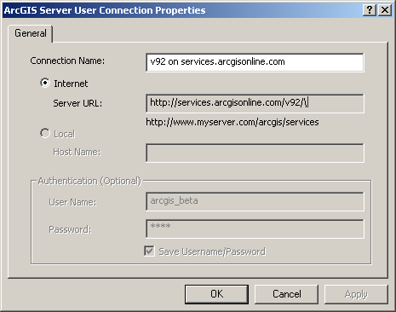

USDA NAIP Imagery and MDOQ
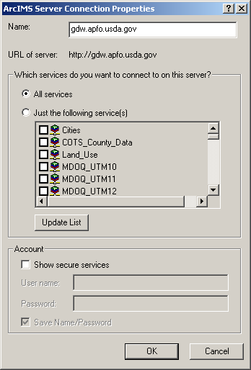

USGS National Image Mosaics
