Health-care scenario

A program manager for the lead hazard program in a county health department wants to create a map showing local pediatricians how lead may be affecting children. They want a map that shows location of homes that were built before 1970 (when lead was still used in paint) and the number of children with elevated blood levels of lead. They can then focus on the problem neighborhoods and set up meeting with physician in those areas to make them aware of populations that are at risk for lead poisoning. He recommends that such populations be screened more carefully.

Download housing variables from Census file SF3

- Using Internet Explorer, go to www.factfinder.census.gov
- Click Data Sets, Decennial Census in the left panel

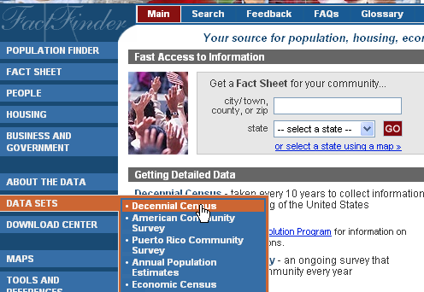

- Click the Census 200 Summary File 3 (SF3) – Sample data radio button and click Detailed Tables.
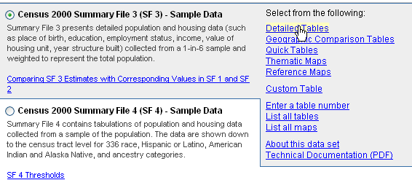

- Click Census Tract as the geographic type, Florida as the state, Miami-Dade as the county, All Census Tracts, Add, and Next

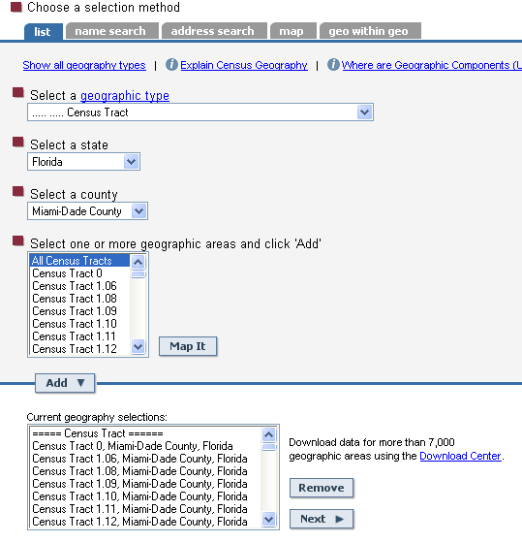
- Scroll down and click H35 Median Year Structure Built from the list of tables, then click Add, and Show Result.

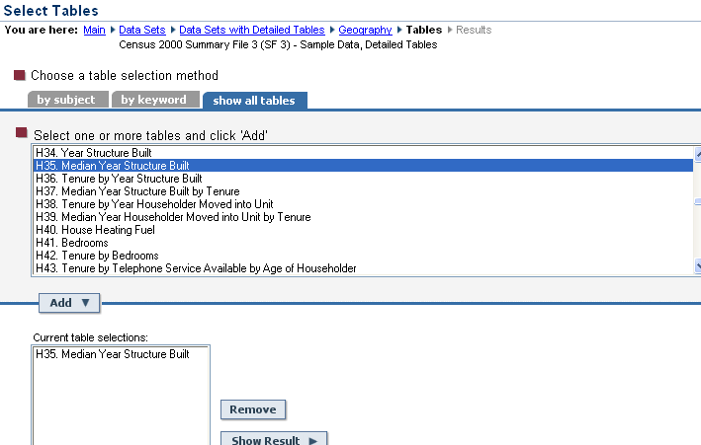

The resultant table shows each census tract and median year structures were built.
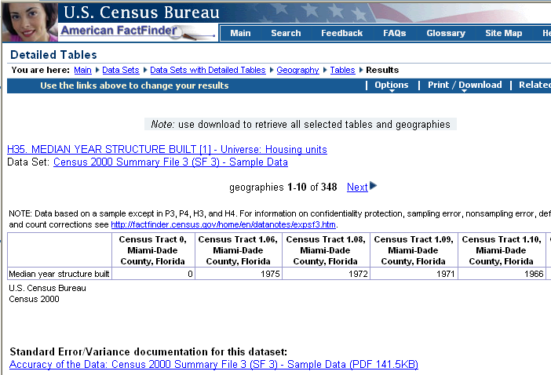

Download census tract housing data from SF3.

- Click Download from the Print/Download menu.
- Click the Microsoft Excel (.xls) radio button and Click Ok.
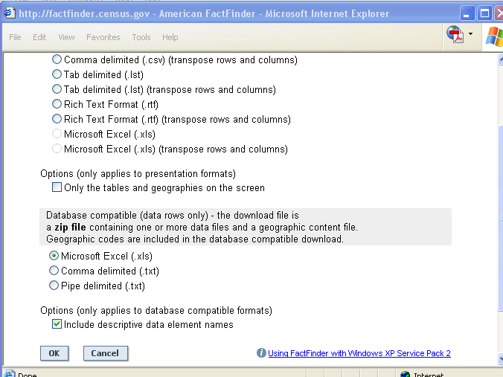

- Save the file in the C:\FloridaTraining folder with the name given to it by the Census Bureau (output.zip) and extract them to the same folder.

Clean census tract SF3 data in Excel

Many downloaded files contain unnecessary text, making them unusable in ArcMap. Here you will do some cleanup in Excel. If you have difficulty in this section, we have provided a copy of the finished product in the C:\FloridaTraining folder.

- Open dt_dec_2000_sf3_u_data1.xls in Microsoft Excel.

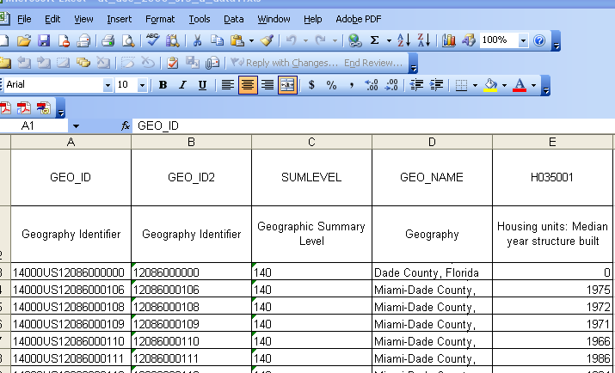
You should see 350 rows of data in the spreadsheet. If your file does not contain all the census tracts, you need to extract the data from fact finder again. Also, remember that there is a copy of file in C:\FloridaTraining folder.

- Click the row selector button at the start of row 1 and click the Align Left Button on the formatting toolbar.

- Click Format, Row, Height, type 15, and click Ok.

- Click in cell B1 and type Tract.

- Click in cell E1 and type YrBuit

- Click the row selector button for row 2, click the Edit menu, and click Delete.

- Click on the column selector D, click the Edit menu, and click Delete.

- Similarly delete columns C then A.

Now you have stripped the table to only the data you need.

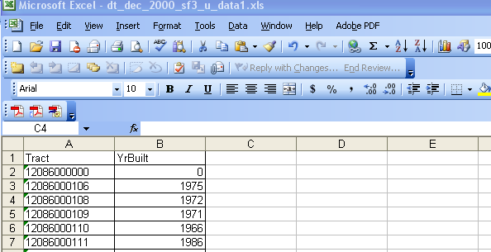

- Click the File menu and click Save As. Change the Save as type to DBF4 (dBase IV) (*.dbf), name the file YrBuilt, click Save, Yes, close Excel, and click No.

Build a map layer for elevated blood levels of lead in children

Query Miami-Dade County Tract from Pennsylvania Tracts

- If necessary, start ArcMap with a new empty map.
- Click the Add Data button , browse to your C:\FloridaTraining folder, and add Florida_Census_Tracts.

This action adds all of the Florida census tracts.

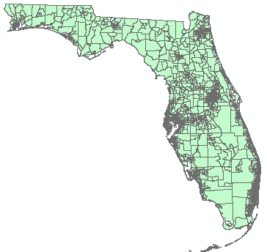

- Click the Selection menu and click Select By Attributes.

- In the list of fields, double-click “COUNTY_FIP”, click the = button, then, in the express box, type “86” just after the equal sign (Do not include the quote around the value).

This action builds an expression to choose census tracts in Miami-Dade County, Fl, whose County FIPS is 86.

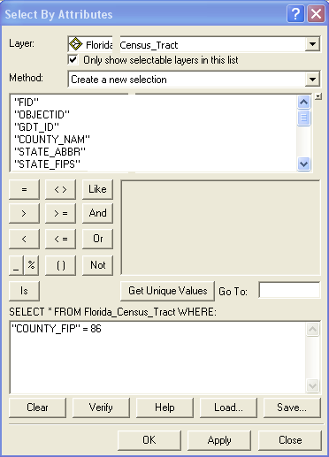

- Click OK.

Only Miami-Dade County tracts are selected.

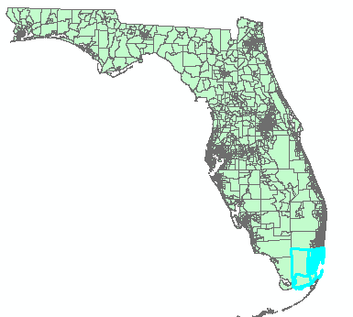

- In the table on contents, right-click Florida_Census_Tracts, click Data and Export Data.

- In the Saving Data Window, browse to your C:\FloridaTraining folder, name the output Miami_Dade_Census_Tracts, click save, OK, and Yes.

- Right-click Florida_Census_Tracts and click Remove.
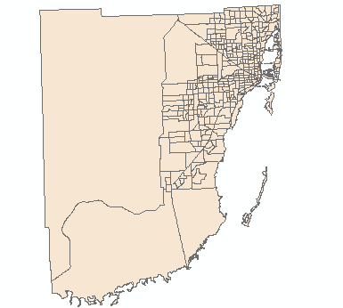

Joining housing and elevated blood cases table to census tract map

Here you will join the housing data to the census tract’s attribute table using the census tract common to both tables.

- In the table of Contents, right click Miami_Dade_Census_Tracts, click Joins and Relates, and click Join.

- In Step 1 of the Join window, select TRACT_KEY from the drop-down list.

- In step 2, browse to your C:\FloridaTraining folder, click YrBuilt.dbf, and Click Add.

- In step 3, select TRACT from the drop-down list.

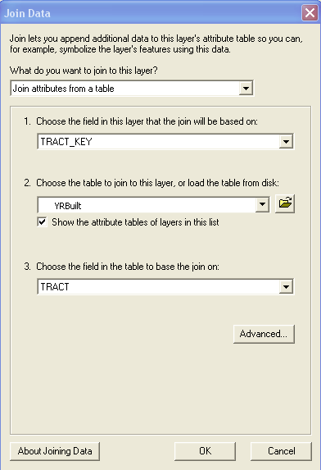
- Click OK and Yes.

- Open the attribute table for Miami_Dade_Census_Tracts and scroll to the right.

Fields from the Attribute of the YrBuilt table are now joined to the Attributes of Miam_Dade_Census_Tracts table and the field names are now prefixed with the names of the source table.

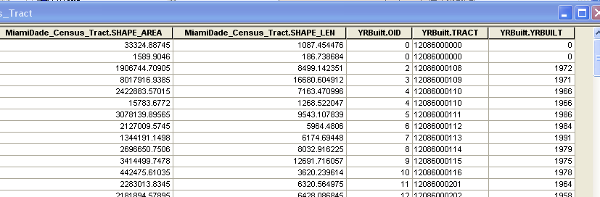

YOUR TURN

Join ElevatedBloodCases.dbf, found in your C:\FloridaTraining folder, to Miami_Dade_Census_Tracts. Use the TractKey field in step 1 of the Join dialog box and the TRACT field in Step 3 of the dialog box.

Permanently join tables

To permanently join these tables you will export the joined layer as a new shapefile. The resulting shapefile will have all the attributes in the joined tables as permanent attributes.

- In the table of contents, right-click Miami_Dade_Census_Tracts and click Data, Export Data.

- Save the output to you C:\FloridaTraining folder and name it MedianYrHousing.shp

- Remove Miami_Dade_Census_Tract from your map.

Create a new personal geodatabase.

- Close ArcMap without saving.

- Launch ArcCatalog

- Expand the Catalog tree in the left panel, if necessary, and click the FloridaTraining folder.

- Click the File menu.

- Click New then Personal Geodatabase.

- Type LeadStudy.mdb as the geodatabase name.

Import a shapefile into the geodatabase

- Right-click LeadStudy.mdb, click Import then Feature Class (single).

- For the Input Features, click the browse button, navigate to C:\FloridaTraining, click MedianYrHousing.shp, and then click Add.

- Type MedianYrHousing as the Output Feature Class Name.

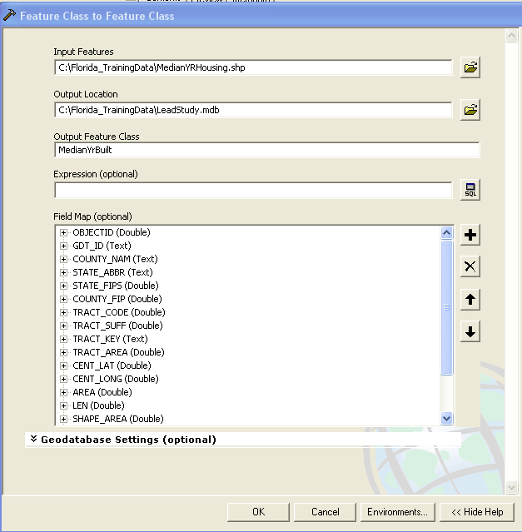

- Click OK and Close once the import is complete.

YOUR TURN

From your C:\FloridaTraining folder import, BASE.DM2K_GDT_PLACE as Municipalities, and BASE.DM2K_GDT_WATER. When you are finished, close ArcCatalog.

Build a lead-study comparison map.

Now that you have downloaded and prepared the spatial and attribute data, you are ready to build a map using this data.

Add map layers

- Start ArcMap with a new empty map.

- Click the Add data button, browse to your C:\FloridaTraining folder, and double-click LeadStudy.mdb

- In the Add Data dialog box, hold down the Ctrl key, click the MedianYrHousing, Rivers, and Municipalities feature classes, then click Add.

- Add another copy of MedianYrHousing.

Symbolize map layers

- Move Rivers to the top of the table of contents and symbolize it with a light blue fill color.

- Move Municipalities second from the top and symbolize it with hollow fill color and a black outline with a width of 1.5

- Right-click the top copy of MedianYrHousing, click Properties, the Symbology tab, Quantities, and Dot density.

- In the field Selection frame, click Elevated_B, and click the arrow button (>) to transfer that column to the main frame.

- Double-click the symbol marker in the right panel and change its color to red, then click OK.

- In the background panel, click the line symbol button 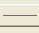 and change the color to No Color.

- Change the dot size to 1.5 and the dot value to 1, and click OK.

A dot value of 1 means that there is one randomly placed dot in a tract for every case that occurred in the tract.

- Symbolized the second copy of MedianYrHousing as a chloropleth map using the YRBuilt with four classes and manual points of 1950,1960, 1970, and 1980 or newer.

- Using a gray color ramp and reverse it so that the highest color value is for the oldest category of median year built. To reverse the color ramp, click on the first symbol in the list and select Flip symbols.)

- Double-click each of the three symbols and change the Outline Color to No Color.
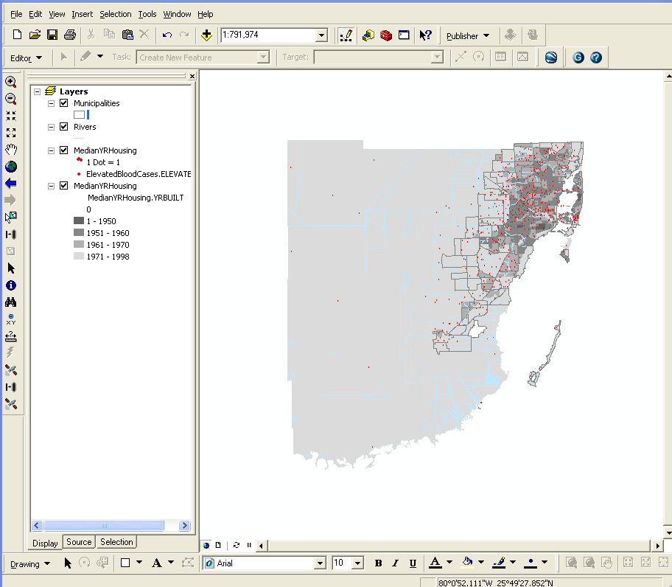

As expected, you can see a correlation between houses built before 1970 and cases of elevated blood levels of lead in children. Probably other factors affect the frequency of elevated lead levels.
- Save your map document as LeadStudy in your C:\FloridaTraining folder and exit ArcMap.

Summary

Preparing data to do analytic work, including GIS-Based studies, require multiple skills and almost always take more time than anticipated. This exercise focused on skills you need for obtaining external data and getting them into the right format for use in ArcMap. You had to find and download needed census data, fix several problems with data values to make them useful, and ultimately join them to a census tract map layer. Then using skills learned in previous exercise generate a map showing results.

