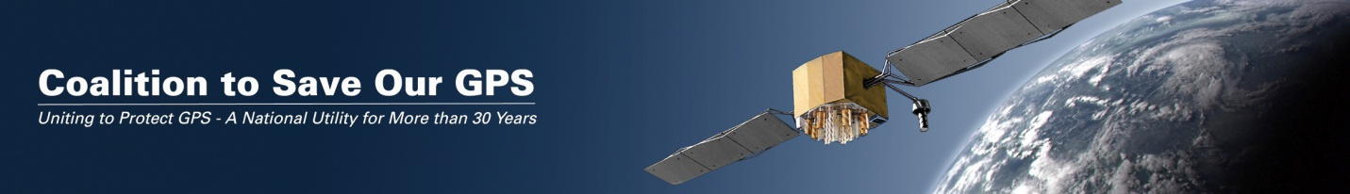

The Coalition will host a Webinar next Tuesday, July 26 at 11AM eastern to update members and potential members on the latest activities and developments related to the LightSquared proposal before the FCC. We hope you will join us and encourage your members, employees and other concerned GPS users to participate. Details below:

Join Us for a Webinar
Update on LightSquared Interference with GPS
Tuesday, July 26,
11 AM eastern
Speakers:
Jim Kirkland, VP and General Counsel of Trimble Navigation
Nick Yaksich, VP, Global Public Policy at the Association of Equipment Manufacturers
Brian Raymond, Director, Technology and Domestic Economic Policy, National Association of Manufacturers

Event number: 922 404 933
Event password: sogps
Event address for attendees: https://saveourgps.webex.com/saveourgps/onstage/g.php?d=922404933&t=a

Teleconference information
-------------------------------------------------------
Call-in toll-free number (US/Canada): 1-877-669-3239

Access code: 922 404 933

Call-in toll number (US/Canada): +1-408-600-3600
Global call-in numbers: https://saveourgps.webex.com/saveourgps/globalcallin.php?serviceType=EC&ED=163524717&tollFree=1

Toll-free dialing restrictions: http://www.webex.com/pdf/tollfree_restrictions.pdf

