2006 HHW and SQG Program Workshop
Hosted by: DEP and Sarasota County
May 1 - 5, 2006
Sarasota, Florida



Sarasota Hyatt on Sarasota Bay
$105/single or double
$115/triple - $125/quad

The "2006 Florida HHW SQG Workshop" rates
are available the weekends before and after the workshop.

Call 1-888-421-1442 to make your reservation.
http://sarasota.hyatt.com/hyatt/hotels/index.jsp

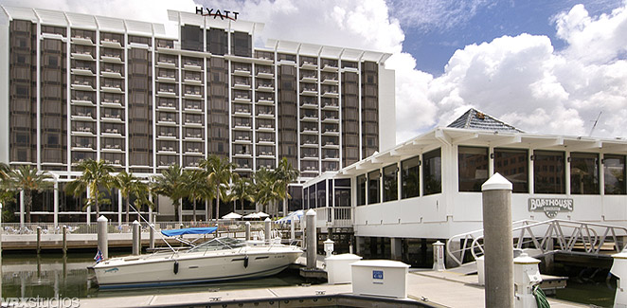

Track 1 | Training
Track 2 | HHW Session or HHW/SQG Session
Track 3 | SQG Session
Track 4 | Tours and Meetings

DRAFTAGENDA

MONDAY, May 1, 2006
 |  | TRAINING | HHW SESSION | SQG SESSION | TOURS & MEETINGS
12:00 pm – 1:00 pm |  | Registration |  |  | Sarasota HHW Facility and Charlotte Co. HHW Satellite Facility Tours
1:00 pm – 5:00 pm |  |  |  | SQG Program Inspector Training

TUESDAY, May 2, 2006
8:00 am – 8:30 am | Registration
 |  | TRAINING | HHW SESSION | SQG SESSION | TOURS & MEETINGS
8:30 am - 12:00 pm |  | Hands-on Unknown Training at Sarasota HHW Facility  (R. Bottcher) | Earth 911 Website and HHW Database Training  (J. Griffith) | SQG Program Inspector Training
12:00 pm – 1:00 pm
1:00 pm – 3:00 pm |  |  | HHW General Session | SQG Database Training
3:15 pm – 5:00 pm
6:00 pm – 8:00 pm

WEDNESDAY, May 3, 2006
7:30 am – 8:30 pm | Registration
 |  | TRAINING | HHW/SQG SESSION | TOURS & MEETINGS
8:30 am – 10:00 am |  |  | WELCOMING CEREMONY  Local Chapters Discussion | Paint Product Stewardship Meeting
10:00 am – 12:00 pm |  |  | DEP Programs and Updates | Paint Product Stewardship Meeting
12:00 pm – 1:00 pm |  | Lunch available for purchase
1:00 pm – 3:00 pm |  |  | Florida School Lab Cleanout Programs | Paint Product Stewardship Meeting
3:00 pm – 5:00 pm |  |  | Pharmaceuticals and Electronics | Paint Product Stewardship Meeting
6:00 pm –8:00 pm | Reception food/drink available for purchase

Thursday, May 4, 2006
7:30 am – 8:00 am | Registration
 |  | TRAINING | HHW SESSION | SQG SESSION | TOURS & MEETINGS
8:00 am - 10:00 am |  | OSHA 8 Hr Refresher  (K. Brown) |  | SQG Case Studies | Scott Paint Tour
10:00 am - 12:00 pm |  |  |  |  | Paint Product Stewardship Meeting
12:00 pm – 1:00 pm
1:00 pm – 5:00 pm |  | OSHA 8 Hr Refresher |  | SQG Case Studies | Paint Product Stewardship Meeting
6:00 pm – 8:00 pm

Friday, May 5, 2006
7:30 am – 8:00 am | Registration
 |  | TRAINING | HHW SESSION | SQG SESSION | TOURS & MEETINGS
8:00 am - 12:00 pm |  | OSHA 8 Hr Refresher  (R. DeHate) |  | School Cleanout Training  (D. Waddell) | Green Building Tour
12:00 pm – 1:00 pm
1:00 pm – 5:00 pm |  | OSHA 8 Hr Refresher |  |  | Eco Tour - Myakka River State Park

