Tuesday - May 2, 2006
Dinner & Hazardous Waste Olympics at Whitaker Park
Located within walking distance from the Hyatt is Whitaker Park. Come out and enjoy an evening filled with great food, good conversation and the exciting premier of the first ever HW Olympics! The park features a nature trail, playground and a fishing pier.
Time: 5:30 pm – 8:00 pm Dinner will be served from 5:30 pm to 6:15 pm.
Cost: $12.00/person – includes a BBQ dinner featuring chicken, pulled pork, coleslaw, baked beans, potato salad, rolls, dessert, ice tea and lemonade.
Olympians Needed! - Sign up on the attached registration form.

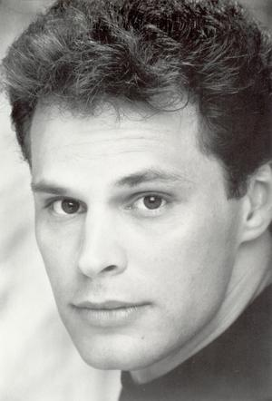
Wednesday - May 3, 2006
McCurdy’s Comedy Theater
Featuring: Tommy Blaze
A Comic On Fire!
You may have seen him on the finale of 'Friends'. Or HBO, MTV, Comic Strip Live, and his own quirky show, The Newz. Or Saturday Night Live. Or the films 'Beverly Hills Cop II' and 'Rumpelstilskin'. Tommy Blaze is as hot as his name, often offering lustful, skewed advice to the lovelorn. A favorite in Las Vegas. Visit Tommy’s website at www.tommyblazecomic.com. Show rating – Adult Standard.
Show Time: 7:30 pm – 9:30 pm
Transportation Provided – Buses will start boarding from the Hyatt at 6:30 pm and will leave promptly for McCurdy’s at 6:45 pm. Buses will return to the Hyatt after the show.
Cost: $12.00/person (18 years old and up only). Price includes ticket to the show and your choice of 2 domestic beers, 2 glasses of house wine, 2 sodas or 2 mixed well drinks. Substitutions on the drinks are not allowed. Snack food and other non-alcoholic/alcoholic drinks are available to purchase at the theater.
Tickets for the evening dinner and entertainment must be purchased prior to the conference.

Complete the registration form for the event(s) that you will be attending and mail along with your payment in the form of check, payable to Lois Rose or cash, to:

Sarasota County Government
8750 Bee Ridge Road
Sarasota, FL 34241
Attn: Lois Rose

Ticket forms with payment must be received by April 20th, 2006. No Exceptions!

Your tickets and receipts of purchase can be picked up at the registration table at the conference.

Name: ____________________________________________________

Organization: ______________________________________________

Daytime Phone Number: _____________________________________

Tuesday – May 2, 2006 Dinner & HW Olympics at Whitaker Park

Number Attending: _________ x $12.00 each = $______________

I would like to take part and be an Olympian at the Tuesday evening event

Yes No

Wednesday – May 3, 2006 McCurdy’s Comedy Theater

Number Attending: _________ x $12.00 each = $_______________

Total Enclosed: $______________ Check Cash

