to: County SQG Program coordinators
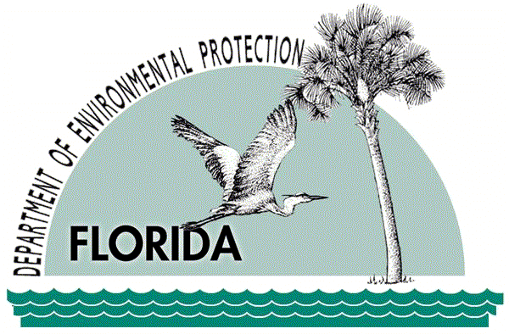
from: glen perrigan, DEP SQG coordinator
subject: SQG PROGRAM data submital

URGENT! PLEASE READ CAREFULLY

The SQG program data is due by June 30 of each year. State law (403.7236, Florida Statute) requires Local Government Information be sent to the Department on an annual basis:
Each county shall transmit the following to the Department, according to guidelines established under s. 403.7226:
- A summary of the information gathered during its local hazardous waste assessment;
- Information gathered from each small quantity generator not notified or verified previously; and
- On-site information gathered from each existing small quantity generator verification.
INCLUDE in your COVER LETTER the following info:
- The year that you started the current five-year cycle.
- How did you update your assessment roll?
- How did you notify businesses of their waste management responsibilities and options (403.7234 F.S.)
- The number of businesses on your assessment roll last year (July 1).
- Your assessment roll for the next year
- Summary information from your inspections:

Verifications | No. | %Verification Rate
On-site | # | %
Phone | # | %
Total | # | %
Glen Perrigan
FDEP, Hazardous Waste Management Section
2600 Blair Stone Rd, MS4555
Tallahassee, FL 32399-2400
ph: 850.245.8749 SC: 205.8749
Fax: 850.412.0528
glen.perrigan@dep.state.fl.us

