Oracle JInitiator is the Java Virtual Machine (JVM) required for entry to the FDEP enterprise applications. Accessing the FDEP production URL via a Windows Internet Explorer session initiates the JInitiator software. JInitiator is intended for installation on each PC, but if necessary, may alternately be installed on a central server for use with terminal services.

There are two mechanisms for acquiring the software:

- Enter the http://depapps.dep.state.fl.us:7777/ URL and automatically download the software. (Note: User must have Power User permissions on the local pc in order to install.)

- Download the software (jinit13122.exe) from the public DEP ftp site at the URL of ftp://ftp.dep.state.fl.us/pub/jinitiator/ then click the file and follow the instructions below.

System Requirements
FDEP supports the use of Oracle JInitiator on the following browser and OS configurations:
Platform | Internet Explorer 5.5 | Internet Explorer 6.0
Windows NT | X | X
Windows 2000 | X | X
Windows XP |  | X

Minimum system requirements for Oracle JInitiator 1.3.1.22:
Pentium 166 MHz or better processor
70 MB free hard disk space before installing
32-48 MB system RAM minimum for running Oracle Forms applications

JInitiator 1.3.1.22 Installation Instructions

- Open the CD or the appropriate directory on your hard drive and click the jinit13122.exe file. Upon clicking the file you will receive the following windows.

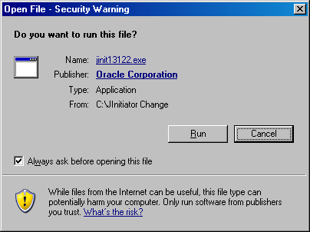

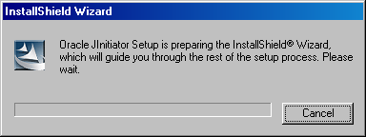

- You will next be prompted for the software destination location. Use the default installation location as displayed in the window (C:\Program Files\Oracle\Jinitiator 1.3.1.22) and click Next.

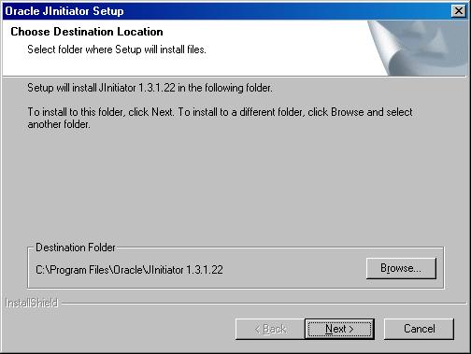

- The installer will display a progress bar and will notify you when the installation is complete.

