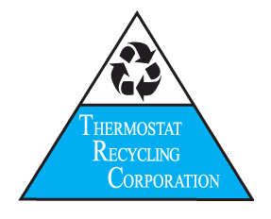
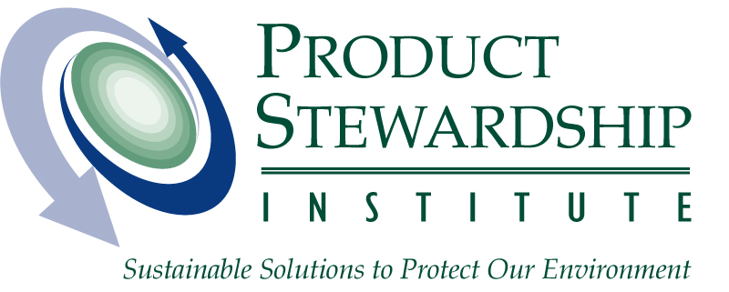

Media Contacts:
Scott Cassel – Product Stewardship Institute Mark Kohorst – Thermostat Recycling Corp.
(617) 236-4855 / scott@productstewardship.us (703) 841-3249 / mar kohorst@nema.org

FIRST NATIONWIDE MERCURY THERMOSTAT

COLLECTION PROGRAM FOR HOMEOWNERS

Five-State Pilot Expands Nationwide to Reduce Mercury Emissions to Environment

ROSSYLN, VA. AND BOSTON, MA. – April 11, 2007 – The Thermostat Recycling Corporation (TRC) and the Product Stewardship Institute, Inc. (PSI) today announced the nation-wide rollout of a mercury thermostat recycling program via local household hazardous waste (HHW) collection facilities. This program expands a successful 8-month pilot project in which 50 municipal HHW facilities in 5 states safely recycled mercury thermostats from residents and their heating and cooling contractors free of charge.
“Homeowners have historically had limited or inconvenient options to recycle their mercury thermostats outside of using a contractor,” said PSI Executive Director Scott Cassel. “This program provides residents with a safe way to recycle, and could save communities hundreds of thousands of dollars in mercury thermostat management costs.”
To take advantage of the national program, homeowners can contact their local, municipal household waste management authorities for information on recycling locations. Consumers can also visit the Earth 911 website by clicking on the following link, and search via city or zip code for the closest HHW facility in their area:
http://www.earth911.org/usa/master.asp?s=lib&a=mercury/recycle.asp.
Mercury pollution is a problem across the nation, with many rivers and lakes subject to mercury fish advisories. People can get exposed to mercury by eating contaminated fish. One of the many sources of mercury deposition in the environment can be mercury-containing products. These products can lead to contamination when thrown in the trash, where they might be crushed, incinerated, or otherwise mismanaged in a way to cause airborne releases, after which mercury falls back to earth in rainwater.
Recycling mercury-containing products is an effective way to address this problem, which is why thermostat manufacturers established the Thermostat Recycling Corporation in 1998. TRC has collected more than 530,000 mercury-containing thermostats since its inception, representing nearly 4,900 pounds of mercury.
“We are delighted that this pilot’s mercury collection effort grew into a nationwide program for homeowners,” said TRC Executive Director Mark Kohorst. “We expect the number of mercury thermostats collected by TRC to increase substantially in future years as a result of the pilot’s national expansion.”
Communities across Illinois, Minnesota, Wisconsin, Washington, and Florida participated in the pilot, which began May 1, 2006, and ended December 31, 2006. The 50 local programs, which operated 72 permanent facilities, 111 mobile facilities, and 14 one-time events, collected and shipped more than 3,000 mercury-added thermostats to TRC for recycling.
“Now that this convenient program is available to homeowners nationwide, we look to the residents of Washington to do their part and recycle the mercury thermostats they replace from their homes,” said Jay Manning, Director of the Washington State Department of Ecology. “Through this partnership with local governments, we can ensure a healthier environment for the citizens of our state and region, and even those beyond.”
PSI facilitated a collaborative national process for this pilot that melded the interests of thermostat manufacturers; retailers; heating, ventilation and air conditioning contractors and wholesalers; and state and local government agencies. Other than a nominal payment for the bin, the industry-run TRC program provided the transportation and recycling of thermostats at no charge to consumers or local governments.

TRC is a private corporation funded by three founding members – thermostat manufacturers Honeywell, General Electric, and White Rodgers – and Nordyne Inc., which joined as a corporate partner this year. It is a voluntary, industry-sponsored program that provides a mechanism for the proper disposal of mercury switch thermostats, regardless of brand. For more information about the TRC program, visit the TRC website at www.nema.org/trc.

PSI is a national non-profit membership-based organization that assists 38 states and 41 local governments in pursuing initiatives to ensure that all those involved in the lifecycle of the product share responsibility for reducing its health and environmental impacts. For information on mercury thermostats, go to: http://www.productstewardship.us/thermostatproject. For a report evaluating the pilot project that led to the national rollout, see: www.productstewardship.us/HHWCollectionPilot.

# # #

