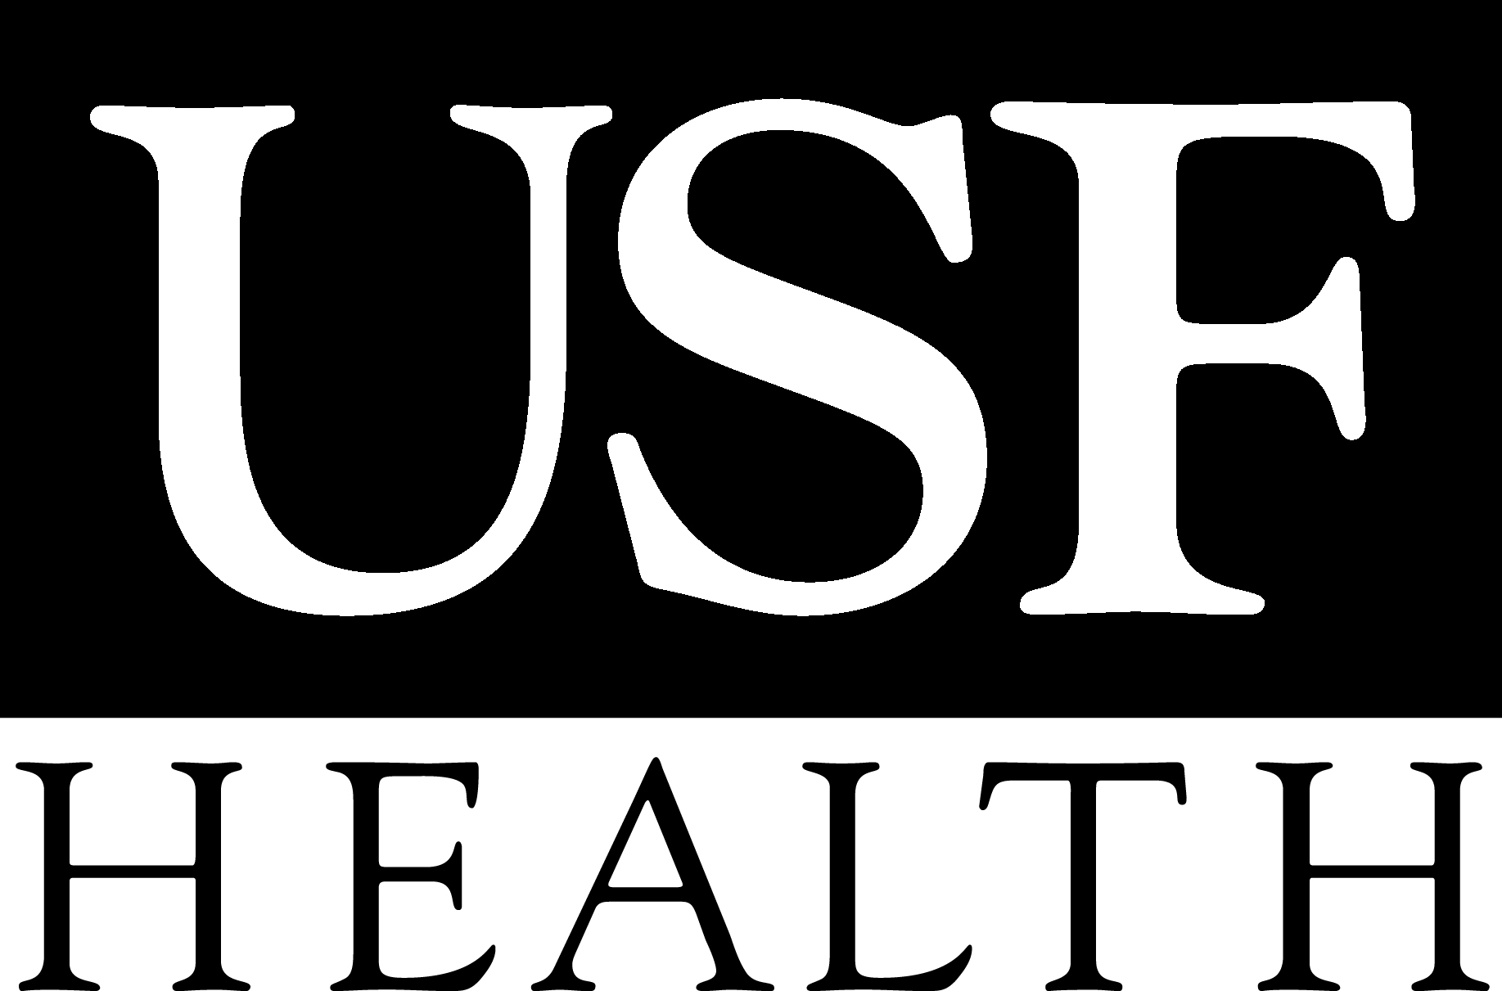

The USF Center for Biological Defense
Presents:
Bioreadiness Training: Friday, November 7, 2008 - 8:00 - 5:00
And
Emerging Infections Training: Fri., December 12, 2008–8:00-12:00
Cosponsored by:
Hendry County Health Department

DAY 1-Friday, November 7, 2008
Time | Topic
7:45-8:00 | Registration
8:00-12:00 | Biological Agent Sample Collection, Bloodborne Pathogens and Emerging Infectious Diseases
12:00-1:00 | LUNCH on your own
1:00-2:00 | Communicating with the Media During a Disaster
2:00-3:00 | Mental Health in the Aftermath of Disaster
3:00-3:15 | BREAK
3:15-4:30 | Avian and Pandemic Flu
4:30-5:00 | Q&A and Evaluations
DAY 2, Friday, December 12, 2008
Time | Topic
7:45-8:00 | Registration
8:00-10:00 | 2-Hour Bioreadiness Training for Healthcare Professionals
10:00-10:15 | BREAK
10:15-11:45 | Methicillin-Resistant Staphyloccus aureus (MRSA)
11:45-12:00 | Q&A and Evaluations

Location: Dallas B Townsend Center (Ag Building) 1085 Pratt Blvd, LaBelle, FL 33975
(Located off of Cowboy Way, across from the Hendry County Health Department)

Pre-Registration is required! There is NO COST to attend this program.

Registration Information

I will attend: ____Day 1 or ____Day 2 or ____Both Days of Training

Name:_______________________________ Company:____________________ Title:______________________
Address:______________________________________________City: _______________ State:_____ Zip:_________
Phone:_________________________ Fax:___________________________ e-mail:_________________________
To return this sheet or for Diana McCluskey, Univ. of South Florida Phone (813) 974-9732
further information, please contact: CBD, 3602 Spectrum Blvd. Fax (813) 974-1479 Tampa, FL 33612-9401 Email: dmcclusk@health.usf.edu

Accommodations for Disabilities: Please notify the Center for Biological Defense a minimum of ten working days in advance of the event if a reasonable accommodation for a disability is needed. Events, activities, and facilities of the University of South Florida are available without regard to race, color, sex, national origin, disability, age, or Vietnam veteran status as provided by law and in accordance with the University’s respect for personal dignity. The Center for Biological Defense at the University of South Florida reserves the right to cancel this activity for any reason whatsoever.

