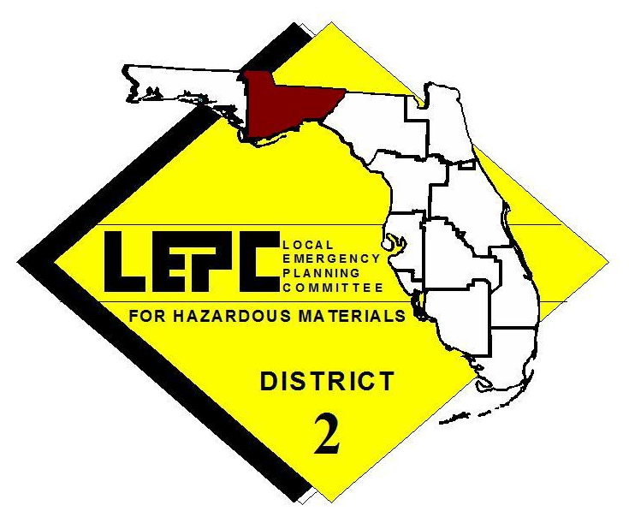
FREE
HazMat IQ
Training

Sponsored by:

District 1 & 2 Local Emergency Planning Committees (LEPCs)

WHERE WHEN
Panama City Beach Fire Station June 19, 2009
2913 Thomas Drive 9:00am – 5:00pm
Panama City Beach, FL 32408

The target audience for this course is for first responders who may respond to hazardous materials incidents. This 8-hour class will cover the HazMat IQ 4-step system that trains responders to efficiently and safely identify chemicals and extremely hazardous substances using “Smart Charts”.

This course will provide participants with a working knowledge of: chemical size-up, streamlined chemical research process, choosing appropriate meters (CGI, PID, FID, pH paper, TIC and KI paper) and determination of, Level A, Level B or turnout gear. Visit www.HazMatIQ.com for additional information.

Class space is limited to 25 students per day and registration is first come, first served. Please do not delay your registration as we anticipate a full class for this highly regarded training opportunity. Contact Chris Rietow at (850) 488-6211 ext. 102 or chris.rietow@thearpc.com for more information.

Pre-registration is required by E-mail or Fax
Please fill out registration and send to: E-mail chris.rietow@thearpc.com or Fax (850) 488-1616

NAME(S):

TELEPHONE:

DEPARTMENT/AGENCY:

DEPT./AGENCY ADDRESS:

