Polk County Communications Division | 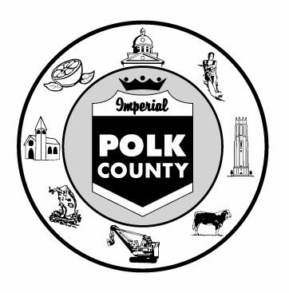 | 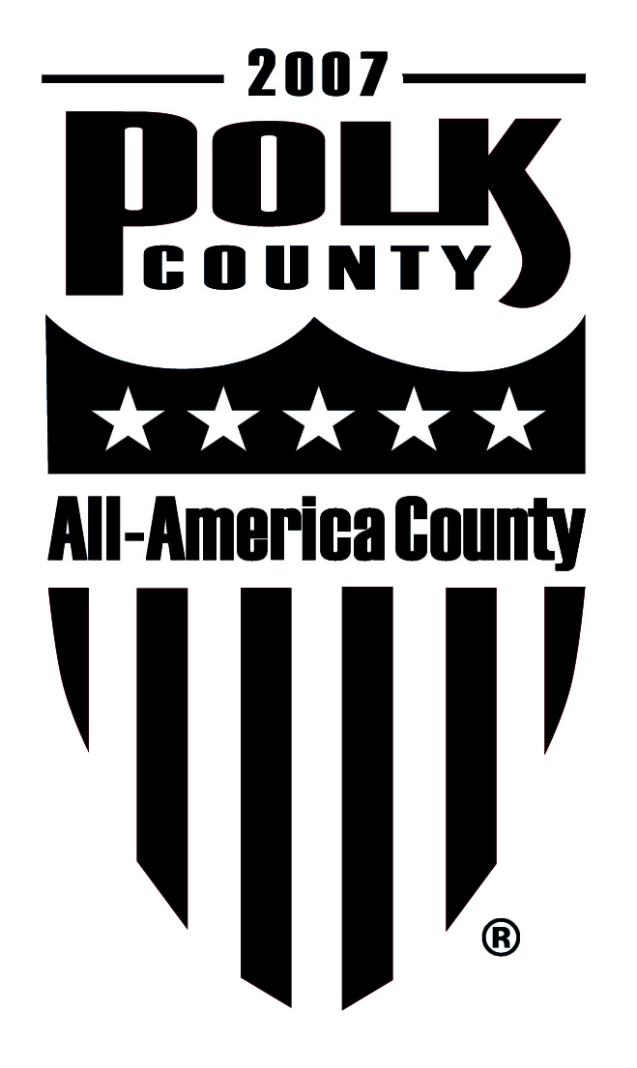 | 330 West Church Street  Drawer CA04  P.O. Box 9005  Bartow, FL 33831-9005  (863) 534-6090  Fax (863) 534-6011  www.polk-county.net
Board of County Commissioners

FOR IMMEDIATE RELEASE
Contact: Betty Henderson, Solid Waste Division
(863) 284-4319

Business Hazardous Waste Collection Event Planned for February
BARTOW, Fla. (January 8, 2010) – Polk County businesses that produce less than 220 pounds of hazardous waste per month can properly dispose of it during an appointment-only special collection event scheduled for February 4 at the North Central Landfill.
Price quotes will be based on the quantity and types of materials to be disposed. Participants must meet registration and paperwork requirements by January 26. Materials being collected include: paint, solvents, waste ink, fluorescent lamps, used oil, antifreeze and other hazardous waste.
Participation is limited. Contact Andrea at (863) 284-4319 ext. 203 or andreastermer@polk-county.net for more information, paperwork and appointment scheduling.
The North Central Landfill is located at 5 Environmental Loop in Winter Haven. Visit Polk County on the web, www.polk-county.net.
-30-

