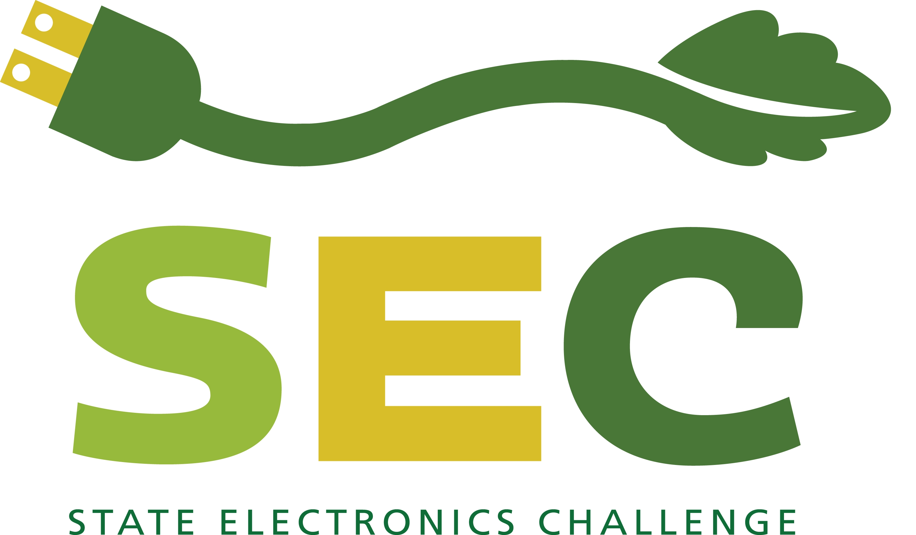

Upcoming Free Webinar
Decrease the Environmental Footprint of Computer Equipment:
An Introduction to the State Electronics Challenge

January 20, 2011
2 pm Eastern/ 1 pm Central/ Noon Mountain/ 11 am Pacific
Pre-registration required.

Learn how to decrease the environmental footprint of computer equipment when you join the State Electronics Challenge. An introductory free one-hour Webinar about The State Electronics Challenge (SEC) will explain how your organization can reduce its environmental footprint, including climate impact, and conserve natural resources through improved management of electronic equipment.

The SEC is a voluntary program, open free of charge to any state, regional, and local government agency. The SEC promotes environmental stewardship of computers – from purchasing “green” computers through power management and responsible end of life management – resulting in measurable reductions in energy, greenhouse gases, solid and hazardous waste, and associated costs.

The SEC has been successfully operating in 16 states for the past three years. Now, thanks to a Great Lakes Restoration Initiative grant and private sector sponsorship, the program is available nationally.

Attend the introductory Webinar to learn how your organization can join the Challenge and benefit from the program’s proven free technical assistance, action plan, implementation tools, and environmental benefits calculations.

Through electronics stewardship efforts, your organization can demonstrate the type of environmental savings accrued by government agencies over the past two years.

If you’re interested in attending the introductory Webinar,
please RSVP by January 19 to Lynn Rubinstein, Northeast Recycling Council Inc., lynn@nerc.org.
In the email, please provide your name, organization, email address and phone number.

You will be provided with call-in instructions and a PowerPoint in advance of the Webinar.

