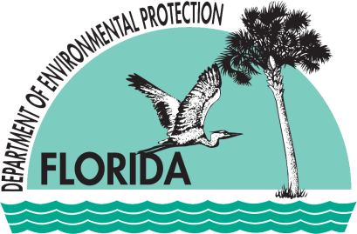 |  | Florida Department of  Environmental Protection  Southeast District  presents
Southeast District Waste Program | Public Records  and  FOIA* Workshop  *Freedom of Information Act
Wednesday, January 9, 2013
1 PM – 3 PM
Solid Waste Authority
Visitor Center
6501 Jog Road, West Palm Beach, FL 33412
Join us for an in-depth exploration of the Waste Program’s publicly-available information resources. Representatives from the Southeast District Public Information Office, Waste Cleanup, Hazardous Waste, Solid Waste, and Storage Tanks will present on the following:
- Public Records Requests 101 – how to get the best results!
- DEP’s Internet Search Tools – Where can I find them? How do I use them? What do my search results mean?
- OCULUS – how to search DEP’s electronic records on permitting, compliance/enforcement, contamination cleanup and monitoring, and much more!
RSVP to Karen Kantor at 561-681-6670 or Karen.E.Kantor@dep.state.fl.us
Space is limited, so reserve your seat today!

