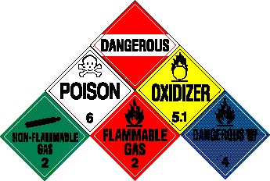
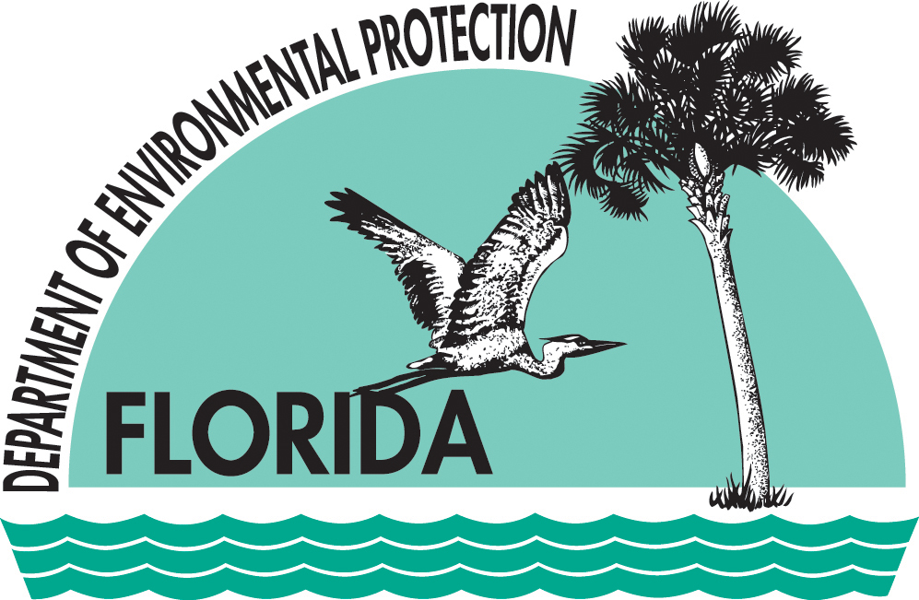

Training Announcement

OSHA
24-hr HAZWOPER
(Hazardous Waste Operations and Emergency Response)

WHERE: FDEP’s Bob Martinez Building, Training Room #603

WHEN: December 3 – 5, 2013 from 0830 – 1700 hrs

HOW: FDEP employees register at: http://tlhadm8/signupweb/
All other government agencies register with Gaby Ortiz by contacting her at 407.897.4341 or gabriela.ortiz@dep.state.fl.us

WHO: Those who have not had an initial 24 or 40-hr HAZWOPER course, or those who have not taken the 8-hr Refresher course within the last two years. This course is open to all government agencies; however, FDEP employees take precedence.

QUESTIONS: Jeff Waters: 407.897.4342 or Jeff.T.Waters@dep.state.fl.us

COURSE INFORMATION:
This is the initial HAZWOPER course that meets OSHA
29 CFR 1910.120 compliance regulations. This course will discuss safety, hazard recognition, toxicology, personal protective equipment and respiratory protection, air monitoring, radiation exposure and monitoring, site entry and reconnaissance, decontamination, and the Incident Command System.

PREREQUISTE: Supervisor’s approval

