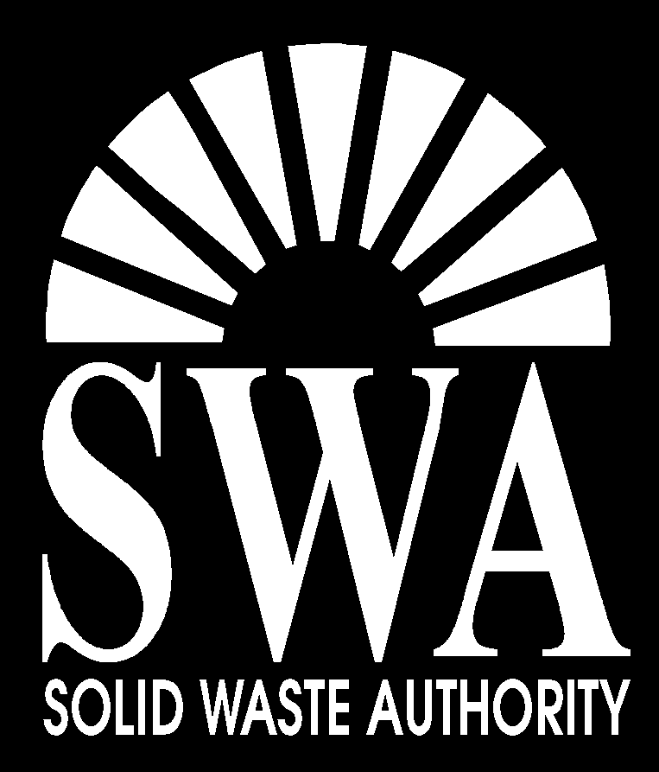

Solid Waste Authority

Human Resources Department

7501 North Jog Road

West Palm Beach, FL 33412

(561) 640-4000 phone

(561) 471-5165 fax

**Special Programs Manager**

**Environmental Dept.**

**$54,788.86 - $65,061.77**

An administrative position involving planning, inspecting and implementing the Authority’s Solid Waste Management Facility Compliance and Permit program. Manage county- wide illegal waste disposal abatement program through contract with the Palm Beach County Sheriff’s Office. Conduct investigations and on-site inspections of SWA permitted facilities and unpermitted facilities to ensure compliance with SWA permits. Serve as technical support for Emergency Management Coordinator and assist with Disaster Debris Management procedures for preparedness, response and recovery. Provide general public, professional organizations and other agencies with Authority related information through oral and written communication.

Bachelors Degree from an accredited college or university with major course work in Environmental Management, Public Administration, Environmental Science and/or related scientific field (i.e. Biology, Geology, etc.) required.

Two (2) years minimum experience in local governmental management, environmental regulation or waste management field. Public speaking skills required. Bilingual preferred.

**EOE/DFWP**

**www.swa.org**